Our operations
Contact Centre phone enquiries
2015–16 | 2016–17 | 2017–18 | 2018–19 | 2019–20
405,916 | 413,775 | 401,069 | 360,399 | 426,615^
^Includes 30,786 COVID-19 hotline enquiries
New bond lodgements ¹
2015–16 | 2016–17 | 2017–18 | 2018–19 | 2019–20
266,868 | 276,448 | 272,939 | 267,210 | 268,188
Number of bonds held ² (30 June)
2015–16 | 2016–17 | 2017–18 | 2018–19 | 2019–20
555,820 | 582,052 | 607,053 | 621,960 | 638,481
Value of bonds ³ ($’m 30 June)
2015–16 | 2016–17 | 2017–18 | 2018–19 | 2019–20
774.08 | 815.56 | 855.58 | 900.8^ | 943.4
^ Figure updated due to the definition of unclaimed bond monies being redefined
Conciliated disputes ⁴
2015–16 | 2016–17 | 2017–18 | 2018–19 | 2019–20
13,259 | 16,566 | 16,657 | 17,627 | 19,882^
^ Includes 1,791 COVID-19 related disputes
Investigations finalised ⁵
2015–16 | 2016–17 | 2017–18 | 2018–19 | 2019–20
690 | 815 | 1,018 | 1,159 | 1,050
Website visits
2015–16 | 2016–17 | 2017–18 | 2018–19 | 2019–20
2,305,020 | 2,494,263 | 2,219,609 | 2,270,595 | 2,939,273^
^ Includes increased traffic during COVID-19 emergency
Operating deficit/surplus ($’m)
2015–16 | 2016–17 | 2017–18 | 2018–19 | 2019–20
(9.8) | 0.7 | (7.9) | 8.6 | (43.3)
- Includes new bond lodgements for general tenancies and rooming accommodation.
- Includes bonds held for general tenancies and rooming accommodation.
- Excludes unclaimed bond monies.
- Methodology changed in this current annual report to more accurately reflect dispute resolution requests that proceed to conciliation in the last five years. This excludes dispute resolution requests where parties subsequently withdrew from the conciliation process or were unable to be contacted.
- Prior to 2017–18, we recorded the number of commenced – but not necessarily finalised – investigations into non-compliance in the financial year.
Our customers
Queensland bonds held by the RTA
Data below is based on bonds held by the RTA as at 30 June 2020.
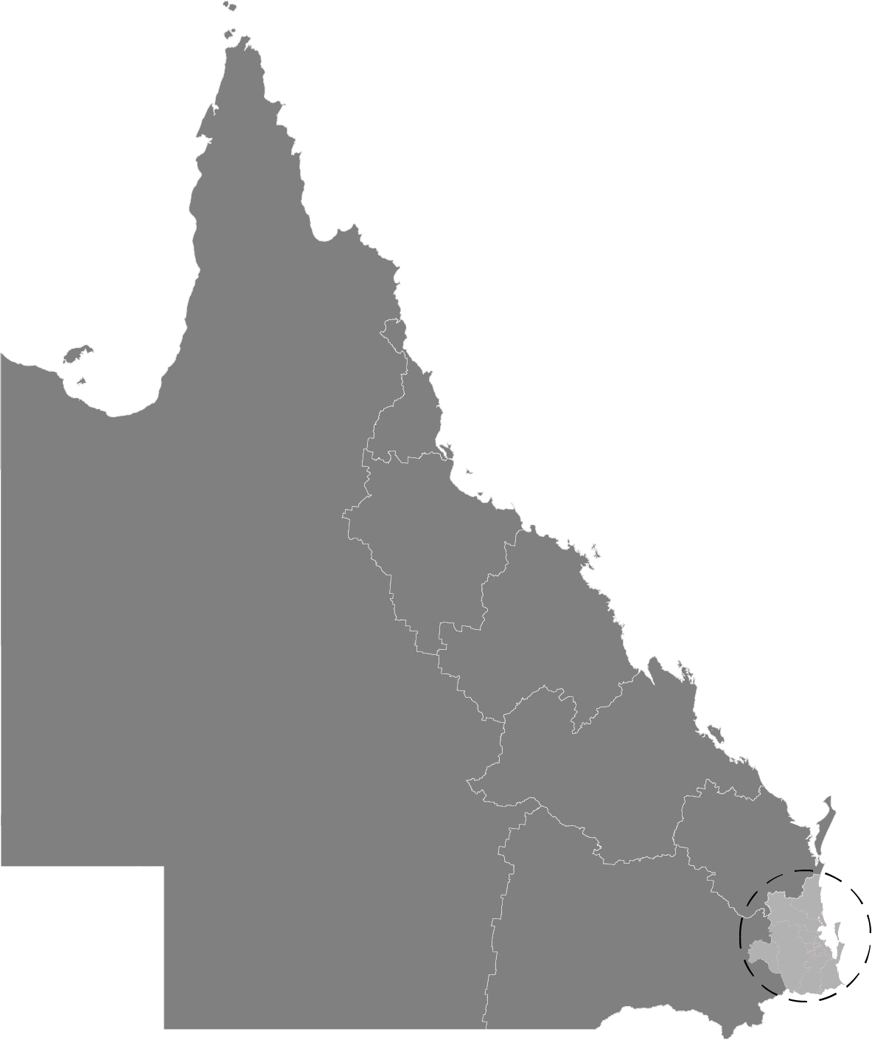
Sunshine Coast
6.4%

Moreton Bay
8.4%

Toowoomba
3.2%

Logan – Beaudesert 6.4%

Gold Coast 13.2%

Ipswich 6.8%

Brisbane 30.8%

Cairns 4.9%
Townsville 4.5%
Mackay – Isaac – Whitsundays 3.5%
Queensland – Outback 1.1%

Darling Downs - Maranoa 2.0%
Wide Bay 4.5%
Central Queensland 4.3%

Total bonds held by dwelling type
Central Queensland 4.3%

The data below shows the total bonds held per dwelling type in the June quarter of each financial year between 2015–16 and 2019–20.

Dwelling type

96.6% of dwellings are houses, flats and townhouses

Who manages bonds?

Approximately 88.5% of rental properties are managed by real estate agents/onsite managers/property managers

Median length of tenancies (months)
The median length of tenancies in Queensland between 2015–16 and 2019–20.

Weekly median rents
The median weekly rents for all dwelling types based on new bonds lodged in the June quarter of each financial year between 2010–11 and 2019–20.
2011 | 2012 | 2013 | 2014 | 2015 | 2016 | 2017 | 2018 | 2019 | 2020
$340 | $350 | $350 | $350 | $350 | $350 | $360 | $360 | $365 | $370

Median rents for Queensland and major centres
Data below is based on new bonds lodged with the RTA in the June quarters of 2019 and 2020. Locations of major centres in Queensland below is based on Significant Urban Areas¹.
 | 2 bedroom flat/unit |  |  | 3 bedroom house
Location | 2019 | 2020 | % change | 2019 | 2020 | % change
Brisbane | $395 | $400 | 1.3% | $380 | $390 | 2.6%
Bundaberg | $235 | $240 | 2.1% | $295 | $300 | 1.7%
Cairns | $300 | $305 | 1.7% | $385 | $390 | 1.3%
Emerald | $210 | $233 | 11.0% | $275 | $300 | 9.1%
Gladstone - Tannum Sands | $158 | $170 | 7.6% | $210 | $236 | 12.4%
Gold Coast - Tweed Heads | $420 | $430 | 2.4% | $480 | $495 | 3.1%
Gympie | $215 | $220 | 2.3% | $290 | $300 | 3.4%
Hervey Bay | $265 | $270 | 1.9% | $325 | $330 | 1.5%
Kingaroy | $205 | $215 | 4.9% | $270 | $275 | 1.9%
Mackay | $245 | $265 | 8.2% | $340 | $360 | 5.9%
Maryborough | $200 | $205 | 2.5% | $270 | $280 | 3.7%
Mount Isa | $220 | $230 | 4.5% | $370 | $380 | 2.7%
Rockhampton | $210 | $220 | 4.8% | $280 | $290 | 3.6%
Sunshine Coast | $365 | $375 | 2.7% | $450 | $460 | 2.2%
Toowoomba | $250 | $256 | 2.4% | $315 | $320 | 1.6%
Townsville | $250 | $265 | 6.0% | $300 | $320 | 6.7%
Warwick | $220 | $215 | -2.3% | $270 | $275 | 1.9%
Yeppoon | $268 | $290 | 8.2% | $330 | $350 | 6.1%
Queensland | $355 | $360 | 1.4% | $360 | $360 | 0.0%

- Australian Bureau of Statistics. (2016) Significant Urban Areas. Australian Statistical Geography Standard (ASGS) (ABS Cat. 1270). The Significant Urban Area (SUA) structure of the Australian Statistical Geography Standard (ASGS) represents significant towns and cities of 10,000 people or more.
Our customised services
In 2019–20, the RTA continued with the staged development and optimisation of Web Services as part of our commitment to customer excellence. We took all opportunities to consult with customers and seek their feedback to improve the support and services we provide, inform future areas of development and training, and ensure steady progress against our strategic objective of ensuring customers value our services.
RTA Web Services
Following the successful launch of the RTA Bond Lodgement Web Service on 24 June 2019, the RTA released a suite of end-of-tenancy Web Services on 2 December 2019. This included the Bond Refund, Bond Disputes and Update Your Details Web Services.
At the same time, and based on customer feedback, RTA ID matching was introduced for managing parties to help securely identify customers and improve the rate of automation within our systems and processes, saving customers valuable time by reducing manual data entry.
A series of enhancements to RTA Web Services was released on 10 February 2020, with a bond increase option introduced as part of the Bond Lodgement Web Service to make essential tenancy transactions even simpler and faster.
Queenslanders have embraced our new RTA Web Services with 45 per cent of single bond lodgements and 72 per cent of bond refunds received via the digital platform in June 2020. Each transaction was also completed in approximately 2.5 minutes on average for an efficient and seamless customer experience. At the same time as celebrating the first year of RTA Web Services, the RTA had received over 100,000 bond lodgements, more than 80,000 bond refund requests and over 30,000 requests to update customer details, processing a total of over 200,000 requests through the digital platform. We look forward to offering a bulk bond lodgement solution in the near future.
Supporting Queenslanders
In response to the COVID-19 emergency and to ensure continued quality support for the Queensland renting community, the RTA engaged the services of an external call centre in April 2020 to operate a dedicated COVID-19 information hotline, which fielded 30,786 COVID-19 phone calls. This hotline transferred to operate under Smart Services Queensland in mid-June 2020. Additional staff and infrastructure, such as offering an SMS service for customers seeking COVID-19 tenancy information, ensured ongoing support for Queenslanders was available seven days a week. During peak times in the RTA Contact Centre, we enabled our customer-focused workforce and called on experienced staff from other areas of the business to help minimise call wait times for customers without sacrificing the quality of service provided.
When mandatory conciliation was legislated through the Residential Tenancies and Rooming Accommodation (COVID-19 Emergency Response) Regulation 2020 (referred to as the COVID-19 Regulations) on 24 April 2020, the RTA Web Services team developed the COVID-19 Dispute Resolution Web Service in two weeks. This made requesting conciliation a quicker process and helped staff prioritise customers impacted by COVID-19.

Customer satisfaction
Customer satisfaction surveys continue to capture the experience of customers who have been in recent contact with the RTA. Survey participants are randomly selected from their interactions with the RTA’s Customer Experience division – including Contact Centre and dispute resolution services – over a set period of time. They are asked to assess various aspects of the customer service received, including rate of response, ease of access, RTA staff performance, service outcome and overall satisfaction with the service provided. An average satisfaction score of 76.9 per cent was recorded in 2019–20 for the delivery of services across Customer Experience.
Bond management
In working towards our strategic objective of providing smart digital services, the RTA released a suite of end-of-tenancy Web Services following the launch of the Bond Lodgement Web Service – to provide customers with a quicker, more efficient and seamless experience in transacting with the RTA.
The new feature of the Bond Refund Web Service enabled the majority of customers, who agree with how the bond refund will be paid, to complete the process online within minutes.
Within the first year of the launch of RTA Web Services, we had reached the milestones of receiving over 100,000 bond lodgement and more than 80,000 bond refund requests via the Web Services digital platform.
To further our strategic objective of customers valuing our services, we have continued to consult with them in the development process for a new Web Service product anticipated to launch in late 2020, which would allow multiple bonds to be lodged online simultaneously in one transaction.
Average processing times
 | Bond lodgements | Bond refunds
All channels (digital + paper) | 5.2 days | 1.5 days

Bond forms processed
2015–16 to 2019–20
 | 2015–16 | 2016–17 | 2017–18 | 2018–19 | 2019–20
Bond lodgements | 341,070 | 412,504 | 424,416 | 418,557 | 396,674  Paper: 288,658  Digital: 108,016
Bond refunds | 349,251 | 329,358 | 321,086 | 312,749 | 296,628  Paper: 158,255  Digital: 138,373
Bond change forms | 65,725 | 122,366 | 72,401 | 69,437 | 77,007
Bond change forms
Change of rental property (Form 3)
Change of property manager/owner (Form 5)
Change of bond contributor (Form 6)
The number of bond lodgement forms and bond refund forms processed both reduced by 5.2 per cent compared to the previous year, consistent with the increase in the median length of tenancies. Other contributing factors for the decline include the implementation of the six-month eviction moratorium during the COVID-19 emergency and the launch of RTA Web Services, which improved accuracy and legibility of information in customer transactions.
Contact Centre
The RTA Contact Centre provides customers with tenancy information and advice, supporting tenants and property managers/owners to make informed decisions. The Contact Centre responded to 426,615 phone enquiries this year, an 18.4 per cent increase from last year. Staff answered an average of 1,610 calls each working day in 2019–20 (up from 1,441 calls per day in 2018–19). RTA customers are also able to self-service with information from other channels and platforms including the website.
Due to the complexity of COVID-19 related tenancy calls, the average talk time has increased to 428 seconds in 2019–20, compared to 397 seconds in the previous year.
Contact Centre phone enquiries

^Includes 30,786 COVID-19 related enquiries
Dispute resolution
The RTA offers a free, impartial and independent dispute resolution service to help tenants, property managers and property owners resolve tenancy disputes and reach a mutually agreeable outcome. This service helps customers avoid the need for legal action through the Queensland Civil and Administrative Tribunal (QCAT), saves customers time and money, and provides them with valuable negotiation and self-resolution skills.
Dispute resolution requests are first assessed to determine whether the matter is suitable for conciliation. Disputing parties are contacted for further information which provides an opportunity for them to have their say. A trained RTA conciliator cannot make decisions, but instead facilitates confidential negotiations between disputing parties, either through one-to-one phone calls or a group teleconference to educate parties on their rights and responsibilities and to help them reach agreement.
In 2019–20, the RTA revised our reporting methodology to more accurately reflect dispute resolution requests that proceed to conciliation. This excludes requests where disputing parties subsequently withdrew from the conciliation process or were unable to be contacted for conciliation.
Conciliated disputes (2014–15 to 2019–20)

^Includes 1,791 COVID-19 related disputes

The COVID-19 temporary amendments to the tenancy legislation passed on 24 April 2020 made conciliation mandatory for disputes relating to rental arrears resulting from the impacts of COVID-19. The RTA moved quickly to increase dispute resolution staff and prioritised conciliation for COVID-19 related tenancy disputes to support the Queensland renting community. Read more about the RTA’s COVID-19 response in the next section.
In 2019–20, the RTA resolved 74.1 per cent of all disputes where parties volunteered to participate.
Over half of the conciliated disputes relate to how a bond will be paid out at the end of a tenancy. Compensation claims for amounts in excess of the bond and claims submitted after the bond had been paid out represent 12.2 per cent of all disputes, while 37.7 per cent of disputes occurred during a tenancy. Such disputes often relate to ending a tenancy, rental arrears, repairs and maintenance.

Dispute reasons
Other:
Overpaid rent
Tenancy database
Rent reduction
Rent increase
No refund form
Excessive hardship
Break lease
Lease variation/extension
Owner wants to move into property
Sale of property

RTA’s COVID-19 response
The impact of the COVID-19 response and recovery has seen the RTA re-focus its services and efforts in the second half of 2019–20 to play a crucial role in supporting the Queensland renting community during the pandemic. Our website was continuously updated to acknowledge and clarify the latest tenancy news, information and changes as announced by the Prime Minister and the Queensland Government.
Following the National Cabinet announcement of an eviction moratorium on 29 March 2020, the RTA engaged a second contact centre to help us operate a COVID-19 hotline and provide tailored information to Queenslanders, including the rental grant administered by the Department of Housing and Public Works. In mid-June, we transferred the operation of the hotline to Smart Service Queensland. As at 30 June 2020, we have received a total of 30,786 calls to this hotline. We also offered an SMS messaging service to provide customers with relevant tenancy information during the COVID-19 emergency without waiting in a phone queue. This SMS messaging service was active for 10 weeks and helped 2,090 customers. More than 78 per cent of those customers were satisfied with the tenancy information received via text messaging and did not need to speak with a Customer Experience Officer.
With COVID-19 significantly impacting parties in a tenancy, conciliation was made mandatory from 24 April 2020 for impacted tenancies prior to seeking a ruling from the Queensland Civil and Administrative Tribunal (QCAT). The RTA quickly prepared to increase staff resources in the dispute resolution team. Conciliators were contacting disputing parties within two business days of receiving a request for COVID-19 related dispute resolution. In these conciliations, a strong focus was placed on reassuring parties, providing information and assisting them to resolve their disputes and reach agreement, or make informed decisions on their next steps.

Calls to COVID-19 hotline: 30,786

Call topics for COVID-19 hotline

This year, 9% of all conciliated disputes were related to COVID-19
COVID-19 conciliation requests received:
52% from tenants/residents, 48% from managing parties
COVID-19 dispute resolution rate:  73.5% | Average resolution time:  7.2 days

Conciliated COVID-19 disputes: 1,791

Conciliation reasons for COVID-19 disputes
Note: A dispute case may have one or more reasons for conciliation; percentages may exceed 100%.

4.7% of conciliated disputes proceeded to tribunal (QCAT)

Parties who were unable to resolve disputes through conciliation were given information on how they may seek a ruling from QCAT if they wished. Note that not all parties took unresolved disputes to QCAT – some chose not to pursue further and others would later reach agreement. Only 85 conciliated disputes have progressed to QCAT, which represents 4.7 per cent of all COVID-19 related tenancy disputes.
Supporting the sector through the pandemic
Following the National Cabinet announcement of a moratorium on evictions on 29 March 2020, the RTA worked closely with the Department of Housing and Public Works and sector stakeholders to support the development and implementation of a corresponding legislative response.
The RTA website was updated continuously with the latest information and news. The importance of working together, behaving reasonably and with empathy while considering individual circumstances was emphasised to encourage parties to self-resolve disputes and sustain tenancies.
With the passing of the COVID-19 Regulations, the RTA updated existing forms and publications to reflect the temporary amendments to the tenancy legislation and developed new forms for new requirements introduced, particularly around domestic and family violence protections and the new ‘show cause’ process for rent arrears.
Information for the RTA website and the Queensland Government Residential Rental Hub website were developed with key changes communicated via supporting resources, such as videos and fact sheets. We also responded to media enquiries, developed tailored customer responses and resources, and answered tenancy questions on the ‘Housing for Queensland’ Facebook page, which is monitored by the Department of Housing and Public Works.
Three webinars were released in May 2020 to provide an overview of the COVID-19 Regulations and the changes affecting tenants, property managers and property owners respectively. The RTA also featured in a four-part video series developed by the Tenancy Skills Institute titled ‘Your Tenancy During COVID and Beyond’, which was released in late May.
The RTA is a member of the COVID-19 Housing Security Sub-Committee of the Ministerial Housing Council and we will continue to work with stakeholders to oversee the implementation of the COVID-19 Regulations. We have been publishing data and information on the legislated mandatory conciliation for COVID-19 related disputes. Media releases on the findings from COVID-19 conciliations and disputes can be found at rta.qld.gov.au/news. The RTA will continue to support Queenslanders and make renting work for everyone through the next legislative milestones and respond to the anticipated impacts on tenancies as the eviction moratorium comes to an end.
Our transition to a remote workforce and training
Our quick transition to a remote workforce was a crucial factor in enabling the RTA to continue servicing the Queensland renting community through the COVID-19 pandemic.
Upgrading workstations to laptop-based setups in February was a timely change as the COVID-19 pandemic began to impact the RTA in mid-March 2020. We prepared staff for working remotely from 16 March 2020 and activated our Flexible Work Policy and Procedure. The RTA began pilot testing for remote capability from home and load capacity to ensure our existing technological infrastructure could support increased demands. Remote working capabilities were further enabled for Customer Experience Officers through the availability of headsets and access to relevant phone software. We also moved our website into the cloud environment in anticipation of the considerable increase in web traffic driven by upcoming announcements.
By 25 March 2020, about 80 per cent of our staff were working remotely and on the same day, our Contact Centre answered over 3000 customer enquiries – double the enquiries on a normal day – to help customers navigate their tenancy challenges in these uncertain times.
Our Quality and Training team played an important role in our quick response to the COVID-19 pandemic. The RTA conducted in-person training for 17 new Customer Experience Officer recruits in March 2020. We also developed supporting resources and conducted training for staff at the additional contact centre engaged by the RTA, to respond to enquiries about government announcements regarding residential tenancies.
The team also quickly adapted to a different mode of delivery for their training. Following the COVID-19 Regulations coming into effect on 24 April 2020 and in line with the recommendations from Queensland Health, training on the temporary regulations was subsequently delivered digitally to 120 RTA staff. We also provided additional training to 32 staff members at the external contact centre, enabling us to respond to the growing number of rental bond and tenancy enquiries. Training was further delivered via a digital platform to a small group of RTA staff to support the legislated, mandatory conciliation process for COVID-19 related disputes.
From March to May 2020, the dedicated work and effort of the Quality and Training team represented an investment totalling more than 550 training hours.

