Residential Tenancies Authority

Annual report
2017-2018

RESIDENTIAL TENANCIES AUTHORITY 2017–18 ANNUAL REPORT ACCESSIBILITY
Communication objective
This Annual Report provides information about the financial and non-financial performance of the Residential Tenancy Authority (RTA) for 2017–18 in accordance with the Financial Accountability Act 2009, the Financial and Performance Management Standard 2009 and Annual Report requirements for Queensland Government agencies, 14 June 2018.

It has been prepared for the Minister for Housing and Public Works, Minister for Digital Technology and Minister for Sport, the Honourable Mick de Brenni MP, to submit to Parliament in accordance with timeframes established within the requirements. It is designed to meet the needs of stakeholders including the Australian and local governments, industry and business associations, community groups, academia and staff.

The report records the RTA’s significant achievements measured against the strategies and services detailed in the RTA’s 2017–2021 Strategic Plan, 2017–18 business and divisional operational plans and the RTA Service Delivery Statement contained within the 2017–18 State Budget (Budget Paper 5).

Making our report accessible
The Queensland Government and the RTA are committed to providing accessible services to Queenslanders from culturally and linguistically diverse backgrounds. If you have difficulty in understanding this report, you can access the Translating and Interpreting Services via www.qld.gov.au/languages or by phoning 1300 366 311 and we will arrange an interpreter to communicate the report to you.

Additional online reporting
The following additional annual reporting requirements can be accessed through the Queensland Government Open Data website (https://data.qld.gov.au):
- Consultancies
- Overseas travel
- Queensland Language Services Policy.

Providing feedback
Readers are invited to comment on this report via email to annualreport@rta.qld.gov.au or by contacting the RTA Contact Centre on 1300 366 311.

Copyright
© The Residential Tenancies Authority 2018
Published by the Queensland Government, September 2018.
1 William Street, Brisbane Qld 4000.

Licence
This Annual Report is licensed by the State of Queensland (Residential Tenancies Authority) under a Creative Commons Attribution (CC BY) 4.0 International licence. In essence, you are free to copy, communicate and adapt this annual report, as long as you attribute the work to the State of Queensland Residential Tenancies Authority Annual Report 2017–18. To view a copy of this licence visit: http://creativecommons.org/licenses/

For more information on access and use visit: https://www.qgcio.qld.gov.au/documents/information-access-and-use-policy-is33
ISSN 18388248
To read the Residential Tenancies Authority Annual Report 2017–18 online visit: rta.qld.gov.au/annualreport
Contents

Letter of compliance 04
Introducing the RTA 05
Chair’s message 06
CEO’s message 07
Our Strategic Plan 2017–21 08
Our operating environment 10
Our clients 11
2017–18 Snapshot 13
Our performance 16
Our performance highlights 2017–18 16
Our contribution to community objectives 20
Our contribution to whole-of-government activities 21
Our management of key community concerns and RTA issues 22
Service summary 23
Our future business directions 24
Our operations 25
Our tailored services 26
Dispute resolution 27
Bond management 28
Our sector 30
Our proactive compliance agenda 33
Our organisation 35
Our organisational structure 36
Board members 37
Accountability and risk management 40
Our Executive Leadership Team 44
Our corporate governance framework 42
RTA support for community 51
Our finances 52
Financial performance overview 52
Management certificate 56
Independent auditor’s report 57
Glossary – acronyms and abbreviations 60
List of tables 61
Compliance checklist 62

Letter of compliance

24 September 2018

The Honourable Mick de Brenni MP
Minister for Housing and Public Works, Minister for Digital Technology, Minister for Sport

GPO Box 2457
Brisbane Qld 4001

Dear Minister

I am pleased to present the Annual Report 2017–18 and financial statements for the Residential Tenancies Authority (RTA).

I certify this Annual Report complies with:
- the prescribed requirements of the Financial Accountability Act 2009 (Qld) and the Financial and Performance Management Standard 2009 (Qld), and
- the detailed requirements set out in the Annual Report requirements for Queensland Government agencies.

A checklist outlining the annual reporting requirements is located on page 62 of this report.
Yours sincerely

Paul Melville
RTA Board Chair

Introducing the RTA

Our Vision
Renting that works for everyone.

More than a third of households in Queensland are rental properties – a significant sector contributing to the state’s economic and social wellbeing.

The RTA plays a pivotal role in maintaining the sector’s stability, supporting and regulating the activities of those who manage rental properties, and enabling all stakeholders to confidently navigate the legal rights and responsibilities governing the market.

Through client-focused services, we strive to balance the social and economic drivers of the sector, to maintain an environment where all parties in tenancy agreements are treated fairly and renting works for everyone.

Our purpose

As a Queensland Government statutory authority, we are an independent legal entity established by the Residential Tenancies and Rooming Accommodation Act 2008 (the Act).
Our purpose is to administer the Act’s provisions and enable stakeholders, clients and the community to understand and comply with Queensland residential rental market regulations.

As well as providing stability for clients, a key function is to manage and safeguard more than half a million tenancy bonds. With bonds totalling in excess of $855 million, the significance of the residential rental sector to the state’s socio-economic fabric is significant.

We are responsible to the Minister for Housing and Public Works, Minister for Digital Technology and Minister for Sport, the Honourable Mick de Brenni MP and governed by a Board of Directors appointed by the Governor in Council.

We provide all stakeholders with impartial free advice via accessible, flexible and targeted services.
To maintain integrity and balance in the sector, we provide statewide tenancy information and support, rental bond management, dispute resolution, compliance investigations and prosecutions, communication, education and stakeholder engagement services.

In Queensland, tenants’ rental bonds must be lodged with the RTA as a legal requirement. As a self-funded entity, the income we earn from investing these rental bonds pays our operating costs. We do not receive any funding from the state’s consolidated revenue.

Our stakeholders

We work with all of the sector’s stakeholders. We assist tenants, property owners and managers, residents and accommodation providers in rental matters concerning houses, flats, rooming accommodation, caravans and even boats. We do this every working day by helping the community to understand and comply with the Act; investigate regulation breaches, manage disputes and ensure proper process for rental bond management. We engage regularly with community advisory groups, industry peak bodies and Queensland Government agencies relevant to our clients to fulfil our strategic objectives and vision.

Our Values
- One Team – We are professional, respectful and work together with a shared goal
- Deliver – We make impartial decisions and own the outcomes
- Listen – We provide responsive, targeted client services
- Innovate – We are adaptable, flexible and embrace change
Chair’s message

I am pleased to present this Annual Report highlighting the sustained efforts of the Residential Tenancies Authority (RTA). Significant contributions from the Board and all RTA staff have kept our focus on our vision – Renting that works for everyone.

The RTA has remained focused on implementing our strategic objectives to enhance client services, deliver lean systems, adapt our people and ensure business sustainability. We have continued to consolidate our systems and processes to expedite interactions with our clients. We have improved our contact centre call waiting times, introduced online services for staff and increased efforts to encourage compliance in the rental market through education and enforcement channels.

During 2017–18, the RTA provided 401,069 responses to phone calls received by our contact centre; 524,710 bonds were processed; 12,646 disputes resolved; 1,018 investigation cases finalised and 10 successful criminal prosecutions concluded in the Queensland Magistrates Courts. The achievement of efficiencies including system enhancements, cross-skilling of staff, real-time performance data and new dashboard reporting has improved our decision-making capability. We continue to develop our capability to enable a flexible and adaptable organisation that can keep pace with the economic and social impacts facing the sector.

The RTA looks forward to working with the Government on the Renting in Queensland initiative.

In a challenging prolonged environment of subdued investment returns, we are focused on investment and financial strategies to improve our revenue streams to cover operational costs. The 2017–18 low interest rate environment was a cause of the operating deficit in 2018 and we are working hard to turn that deficit around in coming years.

After seven and a half years of Board service, Real Estate Institute of Queensland Director (ret.), Deb Duffy was reappointed for a further three years. In October 2017, we farewelled our long serving Chair, Catherine Sinclair and retiring member Penny Gillespie, both appointed in 2013. On behalf of the Board, I express our heartfelt thanks to Catherine and Penny for their dedication to making real changes that are beneficial for all of our clients and all Queenslanders. Two new Board members were appointed, Christine Castley and Rachel Watson, adding to our social dimension with their vast experience in housing policy and transformational change. We welcome their expertise, particularly in relation to the state’s most vulnerable tenants and the issue of homelessness, both of which are key planks of the Queensland Housing Strategy 2017–2027. In February 2018, Darren Barlow, Chief Executive Officer for the past three years, departed after leading the RTA through a period of necessary change in systems and process.

I welcome and look forward to working with our new Chief Executive Officer, Jennifer Morgan. Jennifer brings to the RTA a broad range of experience in the private and public sectors including proven financial acumen, governance and executive leadership skills.

We appreciate the Honourable Mick de Brenni, Minister for Housing and Public Works, Minister for Digital Technology and Minister for Sport for his ongoing confidence in the Board, the leadership team and staff of the RTA. At a recent meeting with staff, the Minister expressed his satisfaction with our collective efforts to meet our clients’ needs, particularly the dedicated work of our frontline call centre staff.

As Chair, I look forward to working with our Minister, Board, CEO, executive leadership team and staff to find ways to maintain and enhance all services to our clients. This is particularly so for young first-time renters, tenants seeking secure long-term accommodation arrangements and the property managers and owners who interact with them. In closing, I sincerely thank the RTA’s staff members for their dedicated contribution and service to Queenslanders. They have embraced immense changes to become an agile and progressive workforce capable of delivering high-quality frontline service to our clients.

Paul Melville
RTA Board Chair
CEO’s message

It was with great pleasure that I accepted the role of the Chief Executive Officer of the RTA in April 2018. I would like to thank the Executive Leadership Team and all the staff at the RTA who have welcomed me into the organisation over the past months.

The RTA staff can take great satisfaction from the positive contribution they make to the lives of a vast number of Queenslanders who use our services for help and information with their residential tenancy matters.

Our clients have access to our contact centre. With nearly half a million phone calls received each year and over two million visits to our website, it is clear that the community places a high value on our services. I thank the RTA staff members for their dedicated efforts in assisting our clients.

In a world moving rapidly as a result of continuous innovation enabled by digital technologies, change is being viewed as normal. The RTA embraces the benefits that change can deliver. In the short time I have been Chief Executive Officer at the RTA, I have come to respect and admire the resilience of our staff during the ongoing journey of change and their continued dedicated efforts to improve our service to our clients.

The RTA staff provide valued information, advisory, education, dispute resolution and compliance services to tenants, property owners and property managers throughout Queensland. The value to the community is reflected in our client satisfaction survey figures for 2017–18, where 80.1 per cent (against a target of 75 per cent) of clients surveyed, rated the RTA at four, or five out of five, across all survey dimensions including delivery of call centre, dispute resolution and bond management services.

The RTA has significantly improved its service delivery capability over the year, with a 52 per cent reduction in average call waiting times from 4.8 to 2.3 minutes in our call centre and a 91.3 per cent success rate for bond refunds processed within two days.

Enhancements to our bond management system have improved our reporting and business intelligence capabilities. This has provided the RTA with an increased understanding and insight into our clients’ needs and preferences for how business interactions could occur, and the communication channels that could be used in the future.

The RTA continues to work to raise the awareness of all the participants in the Queensland private rental market to ensure a high level of understanding of all our clients’ rights and responsibilities. We continue to achieve this through active stakeholder engagement and education, combined with strategies to increase our digital reach.

I look forward to working with the staff, the Executive Leadership Team, the Board, the Minister, the Department of Housing and Public Works and our external stakeholders to ensure renting works for everyone and delivers sustainable and valued solutions.

I look forward to the year ahead.

Jennifer Morgan
RTA Chief Executive Officer

Our Strategic Plan 2017–21

Our Vision
Renting that works for everyone.

Our values

One team – We are professional, respectful and work together with a shared goal
Deliver – We make impartial decisions and own the outcome
Listen – We provide responsive, targeted client services
Innovate – We are adaptable, flexible and embrace change

Our purpose

Empowering people to understand and comply with rental market regulations

Our functions

We support the sector and deliver high quality client services by:
- providing residential tenancy information and community education
- managing rental bonds
- resolving tenancy disputes
- engaging with stakeholders
- monitoring sector data and conducting research
- ensuring compliance with Queensland residential tenancy legislation.

Our commitment to the Queensland Government’s objectives for the community

The RTA supports the government’s commitment to deliver quality frontline services by providing responsive, targeted services that meet our clients’ needs and balance the rights and responsibilities of all stakeholders in Queensland’s residential rental sector.

Our risks

We manage key risks that may affect our ability to achieve our vision and purpose. Mitigation strategies are in place to manage risks that relate to our:
- client satisfaction
- business systems
- financial management
- stakeholder engagement
- data security

Our opportunities

We continually seek better ways to deliver our key objectives. To help make renting work for everyone we will support the residential rental sector, create opportunities to build strong connections with our stakeholders, and put our clients’ needs first. Our opportunities include:
- improvements to the end-to-end client experience
- contributing to the Queensland Housing Strategy 2017–2027
- strengthening stakeholder engagement
- delivering digital engagement strategy
- continuous improvement to business processes
Our objectives and strategies

Lean systems

We will:
- deliver simple, cost-effective systems enabling great client services
- streamline business processes

Performance indicators
- Integrated, modern business systems support value-for-money, personalised client services
- Continual business process improvements and risk mitigation strategies implemented

Enhanced client service

We will:
- deliver secure online services that make renting easier for everyone
- sustain strong relationships with our stakeholders
- maintain our focus on education

Performance indicators
- Clients increasingly satisfied with our services
- Improved stakeholder understanding and engagement

Business sustainability

We will:
- deliver value-for-money services
- grow value through innovation and cost-base efficiency
- address financial sustainability

Performance indicators
- Increased revenue and expenditure controlled
- Innovative business development opportunities developed and investment strategies reinvigorated
- Productive government relationships

Adaptive people

We will:
- support engaged people committed to the RTA’s success
- foster development and innovation with a mobile, flexible and agile workforce

Performance indicators
- High levels of staff engagement within a high-performing culture that supports the capability to meet client service delivery needs
- Refocused learning and development strategies
Our operating environment

Contact centre phone enquiries
2013–14 | 2014–15 | 2015–16 | 2016–17 | 2017–18
414,793 | 408,630 | 405,916 | 413,775 | 401,069

New bond lodgements 1
2013–14 | 2014–15 | 2015–16 | 2016–17 | 2017–18
262,895 | 264,030 | 266,868 | 276,448 | 272,939

Number of bonds held 2 (30 June)
2013–14 | 2014–15 | 2015–16 | 2016–17 | 2017–18
527,695 | 541,442 | 555,820 | 582,052 | 607,053

Value of bonds 3 ($’m 30 June)
2013–14 | 2014–15 | 2015–16 | 2016–17 | 2017–18
721.47 | 744.37 | 774.08 | 815.56 | 855.58

Investigations finalized 4
2013–14 | 2014–15 | 2015–16 | 2016–17 | 2017–18
728 | 543 | 690 | 815 | 1018

Requests for dispute resolution
2013–14 | 2014–15 | 2015–16 | 2016–17 | 2017–18
27,036 | 26,197 | 26,428 | 27,405 | 27,998

Website visits 5
2013–14 | 2014–15 | 2015–16 | 2016–17 | 2017–18
1,639,653 | 1,995,776 | 2,305,020 | 2,494,263 | 2,219,609

Rental sector data requests
2013–14 | 2014–15 | 2015–16 | 2016–17 | 2017–18
214 | 246 | 219 | 230 | 264

Operating deficit/surplus ($’m)
2013–14 | 2014–15 | 2015–16 | 2016–17 | 2017–18
-1.97 | -10.01 | -9.35 | 0.72 | -7.89

1. Includes new bond lodgements for general tenancies and rooming accommodation
2. Includes bonds held for general tenancies and rooming accommodation
3. Excludes unclaimed bond monies
4. Previous annual reports recorded the number of commenced investigations into non-compliance during the financial year
5. Measurement methodology changed in 2012–13
Our clients

34.2 per cent of the population rent

The Queensland population:
- 2.8 million people in 1989-90
- 3.3 million people in 1994-95
- 5.0 million people in 2017-18

Total bonds held: 607,053

Total bond value: $855.6 million

Median weekly rent: $360

Most vulnerable client groups
Rooming accommodation residents, culturally and linguistically diverse people, Aboriginal and Torres Strait Islander communities, people with a physical or mental disability, youth and international students.

0.7 per cent of all bonds held at the RTA are for moveable dwellings. Caravan park rentals are a small percentage of the residential rental market.

2.4 per cent of all bonds held at the RTA are for rooming accommodation (8,200)

77.6 per cent student accommodation

22.4 per cent boarding houses

How we reach our clients
- Outreach
- Website
- Publications
- Media
- Research
- Investigations
- Dispute Resolution Services
- Rental Bond Services
- Client Contact Services

Sector peak bodies
- Real Estate Institute of Queensland (REIQ)
- Property Owners Association of Queensland (POAQ)
- Australian Resident Accommodation Managers Association (ARAMA)
- Tenants Queensland (TQ)
- Caravanning Queensland
- Q Shelter

Dwelling types
Dwelling types rented in Queensland:
- Moveable Dwelling/Site – 0.75%
- Rooming Accommodation – 2.44%
- Other 0.31%
- House – 50.57%
- Flat/Unit – 35.85%
- Townhouse/Semi-Detached House – 10.08%

96.5% of dwellings are houses, flats and townhouses

13.9 months is the average length of a tenancy

Who manages bonds?
- Owners – 9.7%
- Manager/providers – 10.6%
- Community Housing Organisations – 0.9%
- Other – 0.5%
- Moveable dwelling park managers – 0.3%
- Agents – 78.1%

Property managers/agents/onsite managers
- Approximately 89% of rental properties are managed by real estate agents/onsite managers/property managers

Self-managing owners (Landlords)
- Approximately 9.7% of rental properties are self-managed by owners with varying levels of experience
- 3 types of owners:
  - Investor (wealth seminars)
  - Accidental landlord (inheritance or job transfer)
  - Mum and dad investor (retirement income source)

Note: these statistics have been drawn from a variety of sources including the latest census, RTA internal database and information from sector peak bodies and reflect the composition of the sector not confined to 2017–18 financial year.

3 levels of non-student rooming accommodation
- 8,102 rooms available
- 3,480 Level 1 accommodation only
- 2,818 Level 2 accommodation and food
- 1,804 Level 3 accommodation, food and personal care

Rooming accommodation managers/owners vary in their level of experience and tenancy law knowledge. Some properties may have a caretaker with limited knowledge. Student accommodation is a mix of building types, but most are purpose-built high-rise apartments with more than 100 students.

2017–18 Snapshot

Comparison with Australian median weekly rents

 | Two bedroom other dwellings ($) | Three bedroom houses  ($)
Adelaide | 300 | 355
Brisbane | 400 | 390
Canberra | 450 | 495
Darwin | 366 | 477
Hobart | 335 | 400
Melbourne | 440 | 400
Perth | 320 | 330
Sydney | 560 | 520

Real Estate Institute of Australia (REIA) March 2017 quarter data

Median length of tenancies (months)
The median length of tenancies in Queensland between 2013–14 and 2017–18.

Year | Houses | Units | Rooming accommodation
2013-14 | 14.9 | 12.4 | 6.6
2014-15 | 15.5 | 12.7 | 6.5
2015-16 | 15.9 | 12.6 | 6.6
2016-17 | 16.2 | 12.7 | 6.4
2017-18 | 16.7 | 12.8 | 6.7

Weekly median rents
The median weekly rents for all dwelling types based on new bonds lodged in the June quarter of each financial year between 2008–09 and 2017–18.

Year | Houses
2009 | $330
2010 | $330
2011 | $340
2012 | $350
2013 | $350
2014 | $350
2015 | $350
2016 | $350
2017 | $360
2018 | $360

Median rents for Queensland and major centres
Data below is based on new bonds lodged with the RTA in the June quarters of 2017 and 2018.

 | Two bedroom unit |  |  | Three bedroom house
Location | 2017 | 2018 | % change | 2017 | 2018 | % change
Queensland | $350 | $350 | 0.0% | $350 | $350 | 0.0%
Brisbane | $410 | $400 | 2.44% | $425 | $420 | 1.18%
Bundaberg | $238 | $230 | 3.36% | $295 | $285 | 3.39%
Cairns | $300 | $295 | 1.67% | $380 | $375 | 1.32%
Gladstone | $150 | $130 | 13.33% | $200 | $180 | 10.0%
Gold Coast | $440 | $420 | 4.55% | $500 | $475 | 5.0%
Hervey Bay | $270 | $260 | 0.0% | $310 | $310 | 0.0%
Ipswich | $260 | $265 | -1.92% | $310 | $310 | 0.0%
Mackay | $230 | $200 | 13.04 | $330 | $283 | 14.24%
Maryborough | $200 | $200 | 0.0% | $270 | $265 | 1.85%
Mt Isa | $220 | $200 | -9.09% | $360 | $350 | -2.78%
Rockhampton | $210 | $195 | 7.14% | $270 | $270 | 0.0%
Roma | $155 | $150 | 3.23% | $250 | $210 | 16.0%
Sunshine Coast | $365 | $360 | 1.37% | $450 | $440 | 2.22%
Toowoomba | $250 | $250 | 0.0% | $300 | $300 | 0.0%
Townsville | $248 | $240 | 3.23% | $290 | $285 | 1.72%

Queensland bonds held by the RTA
Data below is based on bonds held by the RTA as at 30 June 2018.

Brisbane | 30.55%
Cairns | 5.07%
Central Queensland | 4.34%
Darling Downs – Maranoa | 2.02%
Gold Coast | 13.53%
Ipswich | 6.51%
Logan – Beaudesert | 6.05%
Mackay – Isaac – Whitsunday | 3.61%
Moreton Bay | 8.05%
Queensland – Outback | 1.10%
Sunshine Coast | 6.40%
Toowoomba | 3.23%
Townsville | 4.79%
Wide Bay | 4.72%

Boundaries for this map defined in previous annual reports were based on Australian Standard Geographical Classification (ASGC) Statistical Divisions 2011.

Redefined boundaries for this year’s map are based on the current Australian Statistical Geography Standard (ASGS) Statistical Areas 2016.

Total bonds held by dwelling type
The data below shows the total bonds held per dwelling type in the June quarter of each financial year between 2013–14 and 2017–18.

Year | Houses | % Units | Townhouses | Rooming accommodation | Other dwelling types | Total
2013-14 | 277,951 | 181,534 | 48,891 | 10,171 | 9,148 | 527,695
2014-15 | 282,528 | 187,257 | 52,166 | 10,408 | 9,083 | 541,442
2015-16 | 289,073 | 193,219 | 54,991 | 11,193 | 7,346 | 555,822
2016-17 | 298,920 | 206,341 | 57,346 | 11,969 | 7,476 | 582,052
2017-18 | 306,995 | 217,627 | 61,177 | 14,778 | 6,476 | 607,053

Our performance

Our performance highlights 2017–18

Enhanced client service

Objectives | Aims 2017–18 | Performance 2017–18
Deliver services that make renting easier for everyone | 120-second average answer speed | 138-second average answer speed (48% improvement on 2016–17)
 | Proportion of bonds lodged online (10% or more) and proportion of bond refund forms processed through online channels (40% or more) | 22.5% online lodgements  83.5% refund forms processed through online channels
 | 90% of bond refunds processed in 2 working days | 91.3% of bond refunds processed in 2 working days
 | Less than 17% of finalised dispute cases progressing to the tribunal | 15.6% of finalised dispute cases progressed to the tribunal
 | Disputes finalised on average within 28 days | Disputes finalised on average within 22 days
 | Increased proactive compliance activity | Investigated 2,273 RTRA Act alleged offences (1,956 in 2016–17)  Finalised 1,018 cases – an increase of 203 on last year with existing resources. 95% completed within six month Key Performance Indicator
 | Develop and implement a proactive communications and education program to support the compliance campaign | Completed and supported by these external campaigns:  - Tenancy Laws – Get the FACTS: compliance and enforcement  - Tenancy Laws – Know your RIGHTS  - Operation Bond 2018 – jointly with OFT (DJAG)
Sustain strong relationships with our stakeholders | Create collaborative initiatives with stakeholder groups | Statewide collaboration with Community Legal Centres Qld, REIQ and Queensland Shelter (Q Shelter)  Held industry development forums (stakeholder consultative group) to discuss trends and sector challenges  Hosted the National Tenancy Forum for Australian states and territories  Participated in the Senior Officers Group for Consumer Affairs to consider emerging bond replacement products  Worked with the Department of Housing and Public Works to monitor and minimise the impact of the 2018 Gold Coast Commonwealth Games
Maintain our focus on education | Strengthen stakeholder engagement and deliver a mix of educational programs (digital resources, publications and events) | YouTube visits (16,490) and website visits (2.22m)  Tenancy seminars, webinars, forums, displays, presentations and videos developed and delivered. Clients educated about their responsibilities under the Act when breaches were identified. Nearly half of all investigations (39.4%) involved clients being educated about their obligations under tenancy law
 | Continue to improve access to tenancy information | Improved access through website and other digital resources

Lean systems

Objectives | Aims 2017–18 | Performance 2017–18
Deliver simple, cost-effective systems enabling great client services | Implement scalable infrastructure which supports the RTA initiatives in a cost-effective manner  Implement an organisation-wide Electronic Document and Records Management System (eDRMS)  Enhance data quality processes to ensure data integrity and completeness for all business-critical datasets | Service migration:  Moved some services to the cloud and planned for further migration of infrastructure to a scalable, on-demand cloud delivery model  Migration of external website infrastructure to the cloud:  - Website infrastructure migration to Microsoft Azure  - Delivered benefits included reduced cost and the RTA is better able to manage the ongoing cost  Implementation of myRTA system enhancements:  - Delivered process automation and an improved user experience for RTA staff  - Bond Refund Process Improvements: Refund processes automated further to reduce processing times  - Additional alerts provided to minimise erroneous refunds  - Better classification on refund  - Streamlining of internal controls improving efficiency  - Reduction of duplicated effort in end-to-end process  - Improved quality, reducing rework and downstream impacts of processing activities  Finalised implementation of an enterprise content management system and commenced work on implementation of an electronic records management system.  Commenced work on data quality improvement initiatives and developed business intelligence reporting dashboards.  System monitoring enhancements:  - Automated system alerting enabling a proactive response to emerging system issues  - All system alerts logged and recorded to assist in investigation of system issues  - Plain English error messages enable quick interpretation of issues
Streamline business processes | Implement Dispute Resolution intake model  Increase efficiencies and reduce risk through the implementation of paperless mail distribution processes  Centralise and triage multiple business processes into a single support unit  Revise infrastructure roadmap in line with Queensland Government strategy  Manage business performance through the use of analytics and near real-time dashboard reporting  Implement new quality assurance process and new policies for compliance and enforcement | Dispute resolution intake model implemented  New mail distribution processes have increased efficiencies and reduced risk through paperless mail distribution processes  Support unit created to centralise and triage processes  Unified Service Desk enhancements:  - Reduced average call handling time  - Improved search capabilities  - Quick 360-degree view of client interactions  - Guided call scripts to assist with call quality and provide consistent customer experience  Infrastructure requirements revised  Developing analytics and dashboard  - Implementation of quality assurance process and new policies for compliance and enforcement  Business Intelligence dashboard reporting:  - Reduced manual effort to produce reporting  - Increased visibility of trends and demand to enable proactive decision making  - Near real-time reporting data  - Improved accuracy in reporting as data is sourced directly from systems without any manual intervention  On-demand call recording  - Delivered benefits include reducing risk obtaining financial information from clients

Adaptive people

Objectives | Aims 2017–18 | Performance 2017–18
Support engaged people committed to the RTA's success | Implement the learning and development strategy | Learning and development strategy initiatives implemented within the business
 | Implement the performance management framework and system | Performance framework and system implemented
 | Develop an action plan from Working for Queensland survey results | Action plans developed and undertaken
Foster development and innovation with a mobile, flexible and agile workforce | Develop and implement training calendar | Training calendar developed and implemented
 | Develop, document and implement cross-skilling processes | Cross-skilling processes developed, documented and implemented
 | Adopt flexible work practices | Flexible work practices adopted across different areas of the business
 | Update business systems to create greater flexibility | Business systems implemented which provide web access such as Employee Self Service, myPlace learning and performance

Business sustainability

Objectives | Aims 2017–18 | Performance 2017–18
Deliver value-for-money services | Deliver high-quality, cost-effective services  90% of investigations finalised within 6 months | 95% of investigations finalised within 6 months
Address financial sustainability | 3.2% return on investment | Achieved a 3% return on investment

Our contribution to community objectives

The Queensland Government established four key objectives for the community:
- delivering quality frontline services
- creating jobs and a diverse economy
- building safe, caring and connected communities
- protecting the environment.

We support these objectives for the community through the following services:

Delivering quality frontline services that:
- are integrated, responsive and impartial; meet our clients’ needs; and, balance the rights and responsibilities of all stakeholders across the state’s residential rental sector
- encourage proactive compliance through education and enforcement, stakeholder engagement and increased awareness of RTA services.

Providing high-quality frontline services with dedicated quality and training teams responsible for:
- facilitating regular coaching and training programs to ensure all staff are well equipped to provide an enhanced client experience
- quality monitoring of client interactions each month, measuring the customer service provided against a range of industry benchmarks
- ensuring consistent information is proactively provided to our clients.

We provide free statewide services in:
- bond custodian and management
- tenancy information, education and outreach to all stakeholders
- dispute resolution
- investigation and prosecution of offences under the Act
- monitoring, analysing and reporting sectoral data.

We ensure our services meet the needs of clients impacted by natural disasters and other major events.

Throughout major weather events in 2017–18, the RTA:
- prioritised and closely monitored dispute requests in affected regions
- recorded and monitored contact centre calls to identify potential trends of callers in the impacted areas.

In preparation for the Commonwealth Games the RTA:
- compiled education and information for tenants, property owners and managers who could be impacted by likely tenancy issues generated by the Games, with suggested options provided to minimise the impact
- prepared additional coverage for key business units to assist with potential surges in client demand with staff briefed on likely issues
- prioritised disputes and investigations requests in areas impacted by the Games.

Our contribution to whole-of-government activities

The RTA works collaboratively with various government agencies including the Office of Fair Trading (OFT), Queensland Police Service (QPS) and Queensland Fire and Emergency Services (QFES), gathering intelligence about compliance matters in the sector, conducting investigations and bringing about enforcement action.

We liaise regularly with the Queensland Civil and Administrative Tribunal (QCAT), Department of Housing and Public Works (DHPW), Department of Justice and Attorney-General (DJAG), Department of Premier and Cabinet (DPC) and Queensland Treasury.

We continued to provide submissions to other legislative reviews that affected the sector, including Body Corporate and Community Management Act 1997, Building Units and Group Titles Act 1980 and Labour Hire Licensing Act 2017, and to support government initiatives such as the Tingles from Taps campaign through the Office of Industrial Relations.

We also supported the Introduction of the Housing Legislation (Building Better Futures) Amendment Act 2017, which amended the Residential Tenancies and Rooming Accommodation Act 2008 to allow minimum standards for rental properties to be prescribed in the regulation. The minimum standards will be introduced after extensive consultation with the sector, and the work will be led by the Department of Housing and Public Works.

As a member of the Commonwealth Games Housing and Homelessness Cross Agency Coordination group, we linked with other agencies to address potential housing and homelessness issues arising from the Gold Coast Commonwealth Games in April.

Our education strategy developed this year links to the broader Education Strategy for Queensland.

Collaborative stakeholder relationships

In 2017–18, we responded to 264 requests (230 last year and 219 in 2015–16) for rental data and other statistical information from various government agencies, stakeholders, the housing industry and the community.

Client enquiries, feedback, types of dispute resolution requests and tribunal orders are all used to monitor the Act’s operation. We also analysed operational data and monitored emerging trends for targeted, statewide community education activities.

We strengthened collaborative sector relationships through Industry Development Forums (IDFs), individual liaison, reference groups and targeted consultation to review and monitor the operation of the legislation.

Stakeholder groups include:
- Real Estate Institute of Queensland (REIQ)
- Property Owners Association of Queensland (POAQ)
- Australian Resident Accommodation Managers Association (Queensland) (ARAMA)
- Tenants Queensland (TQ)
- Caravan Parks Association of Queensland (CPAQ)
- Queensland Shelter (Q Shelter)

Compliance operations also provided an opportunity to understand the needs of our stakeholders. Formal and informal meetings with property managers, Rent Connect and TQ/QSTARS provided opportunities to discuss and address compliance in the sector.

Our management of key community concerns and RTA issues

Creation of a National Policy Forum

This year we were pleased to initiate and host the inaugural National Policy Forum for tenancy law experts from all Australian states and territories. The two-day event featured wide-ranging discussions about emerging issues as well as continuing challenges. It has laid the foundation for ongoing relationships between the jurisdictions. Participants supported the continuation of the forum, with South Australia taking the lead for 2019.

Domestic and family violence

Under the government’s ‘Not Now Not Ever’ anti-domestic violence reforms, the RTA has made relevant changes to its advisory booklets and online resources for tenants.

The growing community debate about domestic and family violence during the year prompted us to revise our publications and website to increase the information available to stakeholders about how to protect the rights of tenants. Tenants can apply for an order regarding their tenancy under the RTRA Act. The Act gives rights to people in a domestic relationship whether or not they are named on the tenancy agreement.

This includes a spouse (including a defacto), a dating partner, a family member or an informal carer. The RTA’s Pocket guide for tenants must be provided – by law – to all tenants as part of the renting process. By including information to support those impacted by domestic and family violence in our Pocket guide for tenants – houses and units (Form 17a) booklets, the RTA is contributing to an increased awareness of the rights, responsibilities and obligations of parties to a tenancy when domestic and family violence occurs.

Service summary

As part of its ongoing program of transformational change, in the preceding 2016–2017 financial year, the RTA laid the foundations for this year’s positive results by:
- implementing an intake model to ensure responsive frontline client service delivery in dispute resolution
- enhancing and promoting eServices facilities, which resulted in a 50 per cent increase in the electronic submission of forms for faster finalisation of client transactions
- implemented a proactive legislative compliance agenda in partnership with sector stakeholders and other government agencies

This year, we have consolidated the gains in delivery of services to clients by:
- leveraging the recently implemented client management system to produce data analytic reporting which identifies improvements to frontline service delivery
- continuing to focus on business process improvements to ensure integrated client service delivery
- supporting a fair and balanced rental sector by increasing the number of proactive investigations into breaches of the Act
- improving data analytic reporting that delivered improvements to frontline service delivery which reduced call wait times and enabled targeted delivery of services to high priority cases
- implemented efficiency improvements in bond refund processing, resulting in improved client experience.

RTA Service Delivery Statement

The Queensland Government’s Financial and Performance Management Standard 2009 (FPMS) requires the RTA to consider both financial and non-financial performance information (including measures and targets) it will report as part of its Service Delivery Statement (SDS) in the annual State Budget. The SDS documents are a key accountability mechanism subject to public scrutiny and form the basis of questioning during the parliamentary estimates hearings. As part of Budget Paper 5, the statement reports on service standards and targets for the RTA’s service areas, including estimated actual results against the targets set in the previous year’s SDS. In accordance with Department of Premier and Cabinet Annual Report requirements, details of the RTA’s performance contained in its 2017–18 State Budget Service Delivery Statement are:

Residential Tenancies Authority | Notes | 2017–18  Target/Est. | 2017–18  Est. Actual | 2018–19  Target/Est.
Service area: RTA
Service standards  Effectiveness measures  Proportion of disputes resolved after parties participated in the conciliation process |  | 70% | 73% | 70%
Overall client satisfaction |  | 75% | 80.1% | 75%
Efficiency measures  Average annual return on investment |  | 3.2% | 3.2% | 2.9%
Total cost for RTA output (excluding grants) as a proportion of the value of bonds held |  | 4.0% | 4.0% | 4.0%

Actual results for 2017–18

The service delivery statement, produced in February each year for the State Budget, does not constitute a full financial year. End of financial year actual figures for 2017–18 are:

Service Standards | Result
Effectiveness measures  Proportion of disputes resolved after parties participated in the conciliation process | 73.0%
Overall client satisfaction | 80.1%
Efficiency measures  Average annual return on investment | 3.0%
Total cost for RTA output (excluding grants) as a proportion of the value of bonds held | 4.0%

Our future business directions

In 2018–19, the RTA is committed to contributing to a responsive government, as set out in Our Future State: Advancing Queensland’s Priorities. The RTA’s focus is to modernise by undertaking a full review of its processes and client interactions to enhance the customer experience. The RTA is exploring a number of modernisation avenues in consultation with customers and other stakeholders.

Examples of the RTA’s renewed focus are:
- enhancement of the bond management system, which has considerably improved reporting and process tracking through business intelligence tools. The leveraging of this provides the base for near real-time reporting and will give the RTA the information to better read trends and anticipate peak periods.
- exploration of a simple and easy-to-access online tool for customer interaction including form lodgement and web chat options based upon clients’ digital preferences.

Through the process of modernisation, the RTA will also create a more economically sustainable and technologically robust platform to service Queenslanders well into the future. In 2018–19, we plan to:
- improve data reporting and analytics for use throughout the RTA which will provide timely access and analysis of RTA data to inform decision making and drive performance improvements in client services, enabling the RTA to better support the rental community
- implement business process improvements focussing on quality which will result in reduced call handling times in the contact centre, improving client experiences
- cross-skill frontline staff allowing the RTA to better respond to client demands
- review the RTA’s Multicultural Plan
- proactively engage with identified high users of the RTA Dispute Resolution Service to reduce dependency through knowledge transfer and upskilling in self-resolution strategies increase use of electronic communication with clients, potentially including online web chat
- improve data collection to measure and monitor sector compliance with RTA legislation
- work with the Department of Housing and Public Works to engage with the sector and modernise the legislative framework
- drive compliance with tenancy legislation through increased education services delivered to tenants, property owners/managers and industry bodies
- improve IT disaster recovery processes by delivering a secure and robust technical environment which will support improved client service experience when required
- enhance business continuity capabilities to improve sustainable service delivery
- determine technical capabilities required to ensure service channels meet the needs of the residential rental sector.

Our operations

Our clients

- 2,219,609 website visits
- 401,069 phone enquiries
- 73% disputes resolved
- 272,939 new bonds lodged
- 80.1% of clients highly satisfied with contact centre service

Future priorities

- Explore a simple and easy-to-access online tool based upon clients' digital preferences.
- Contribute to the Queensland Housing Strategy 2017–2027.
- Enhance the bond management system.
- Implement business process improvements focusing on quality.
- Focus on investment and financial strategies to improve revenue streams.

Our tailored services

“The RTA’s focus on client needs is creating significant operational change and a shift in mindset and culture.”

A large part of the RTA’s role is to provide clients with clear, concise tenancy information. We do this through our contact centre, a comprehensive website, and an engaging suite of publications, which all help tenants, property managers/owners and stakeholders gain a clearer understanding of Queensland tenancy law.

In 2017–18, we continued to enhance frontline services with improved business analytics and reporting capabilities.

Reporting has increased management’s access to real-time operational information and historical data, enabling improved workforce forecasting and scheduling to align frontline services with client demand. This has improved response times to client enquiries significantly by reducing call wait times and providing improved consistency in performance for bond lodgement and refunds.

We have continued to develop our workforce capabilities, providing cross-skilling opportunities for staff. This has increased our capacity to react dynamically to short-term fluctuations in demand, rapidly moving resources to meet client needs. The increased flexibility of resources enabled us to meet our targets successfully without affecting service delivery across the RTA.

This year we have continued to enhance our internal systems to reduce the time spent completing administrative tasks, freeing more time to service our clients. This includes a new interface for contact centre staff to locate client details faster, an updated conciliation and refund agreement template for our dispute resolution service, and automation of the way forms and emails are processed.

To ensure we are moving in the right direction, we take every opportunity to gather client feedback through post-call surveys, client satisfaction surveys, online feedback, workshops and focus groups.

Periodically we run client satisfaction surveys for our service delivery, capturing the experience of clients who have been in contact recently with the RTA. The surveys focus on measuring the satisfaction level for timeliness, ease of access, RTA staff performance, outcome and overall satisfaction with the service provided.

We conducted the client satisfaction survey first in April 2017 with survey participants selected without prejudice from interactions with the RTA’s Contact Centre and, as of June 2018, dispute resolution services through a set period.

Improvements have been recorded across all satisfaction measures this year. Our delivery of contact centre and dispute resolution services received an average score of 80.1 per cent (against a target of 75 per cent); rating these services at four or five out of five across all survey dimensions. The timeliness of the service provided had the greatest increase, improving from a rating of 63 per cent in April 2017 to 81 per cent in the most recent survey of June 2018.

Client phone enquiries

The RTA Contact Centre’s focus is to provide clients with tenancy information and advice to enable them to make informed decisions. This year, the Contact Centre responded to 401,069 phone enquiries (down three per cent from 413,775 calls in 2016–17). Staff answered an average of 1,591 calls each working day in 2017–18 (down from 1,649 in 2016-17).

Calls answered by RTA’s Contact Centre
2013–14 to 2017–18

Year | Total
2013-14 | 414,793
2014-15 | 408,630
2015-16 | 405,916
2016-17 | 413,775
2017-18 | 401,069

As well as the decrease in volume, average talk time decreased to 382 seconds in 2017–18 from 393 seconds in 2016–17. A continued focus on providing a quality client service and increased staff confidence in using the RTA’s CRM database have contributed to this marginal decrease in call length.

The average wait time for callers was 138 seconds compared with 288 seconds in 2016–17, representing a 52 per cent improvement. We achieved this by utilising our cross-skilled staff to boost the number of staff answering calls while maintaining existing staffing levels.

Call quality remained consistently high with monthly post-call surveys continuing to record positive results. Over July – June 2018, 82.9 per cent of clients surveyed scored the quality of service provided by the contact centre as being very good or excellent.

Dispute resolution

The RTA provides an impartial, independent dispute resolution service to tenants, property managers and property owners. This conciliation service saves clients time and money by helping them resolve disputes without the need to go to the Queensland Civil and Administrative Tribunal (QCAT). This year, a record number of 27,998 dispute requests were submitted for our resolution (compared to 27,405 last year) as the number of Queenslanders renting increased.

Dispute resolution requests received
2013–14 to 2017–18

Year | Total
2013-14 | 27,036
2014-15 | 26,197
2015-16 | 26,428
2016-17 | 27,405
2017-18 | 27,998

Intake

The RTA’s dispute resolution model includes a strong focus on intake methodology. Initial assessment of a dispute resolution request will establish client negotiability and disputing parties are contacted for an opportunity to have their say on the matter. The intake officer then gathers all information to determine the most suitable and efficient method of resolving the dispute.

Conciliation

Where possible, matters are resolved during intake or a teleconference is organised for parties to discuss their issues. A conciliator facilitates this conversation to educate parties involved, help them involved reach an agreement and, where applicable, maintain their ongoing relationship. When people participated in the conciliation process in 2016–17, 70.8 per cent of disputes were resolved. The figure has increased to 73 per cent for 2017–18.

Reasons for disputes

Disagreement over how a bond will be paid out remains the most common form of dispute, accounting for 52.08 per cent of all disputes received in 2017–18. Claims greater than bond and repairs are the next most common areas of disagreement. Compensation claims for amounts in excess of the bond and claims submitted after the bond has been paid out represented 16.51 per cent of all disputes while 31.4 per cent of disputes occurred during a tenancy. Such disputes often related to ending a tenancy, rental arrears, repairs and maintenance.

All reasons
Bond | 52.08%
Claim Greater than Bond | 16.51%
Repairs | 7.91%
Other | 23.49%
- Ending a Tenancy | 3.96%
- Rent Arrears | 3.10%
- Non-lodgement of Bond | 2.82%
- Water Charges | 1.86%
- Entry | 1.85%
- Tenancy Database | 0.56%
- Overpaid Rent | 0.38%
- No Refund Form | 0.23%
- Rent Increase | 0.19%
- Other | 8.55%

Bond management

Bond management has realised the benefits of enhanced data and analytics capabilities, due to the internal systems upgrades delivered in 2016–17.

Improved access to near real-time operational and historical data has provided the platform for improvements to workforce forecasting and scheduling in 2017–18, enhancing the ability to align resourcing with the cyclical nature of demand for bond services. A significant focus on quality and streamlining bond processes resulted in improvements to the accuracy and efficiency of processing activities. These advances provided the platform for consistent and timely bond processing, contributing to the positive experiences clients enjoyed with our services.

This year recorded a continuation of the strong upward trend for online submissions, with 83.5% of refunds received through digital channels – a clear statement of our clients’ desire to transact online with us.

New bonds
Growth -1.29%
2016-17 | 2017-18
276,448 | 272,939

Bond processing times
Lodgements 92.8%
Lodgement documents processed in 3 days
2016-17 | 2017-18
412,504* | 424,416

Bond processing times
Refunds 91.3%
Refund forms processed in 2 days
2016-17 | 2017-18
329,538 | 321,086

* Following system changes bond lodgements are now recorded differently. The 2016–17 figures include the total number of bond lodgement documents sent to the RTA.

Managing bonds

A slight decrease in new bonds lodged with the RTA was experienced; 272,939 compared to 276,448 in 2016–17, down 1.3 per cent, following a 3.6 per cent increase in the previous year.

Bonds refunded in 2017–18 rose by 3.2 per cent to 1011 per day (980 in 2016–17). Despite the increase in volumes, clients consistently enjoyed timely disbursements, with 91.3 per cent of bond refund requests processed within two working days, exceeding the target of 90 per cent, and representing a 14.3 percent improvement on 2016–17 (79.9 per cent).

Our online channels continued to attract increasing numbers of clients, with growth experienced in the proportion of both bond lodgements and bond refunds submitted online.

An online forms upload facility (via the RTA website) is available to all clients. Additionally, property managers/owners who manage multiple tenancies are able to register for eServices, the RTA’s secure online bond management facility.

Bond forms processed
2013–14 to 2017–18

Year | Bond  lodgements | Refunds | Bond change forms (Forms 3,5,6)
2013-14 | 345,474 | 335,108 | 62,421
2014-15 | 341,530 | 345,301 | 63,882
2015-16 | 341,070 | 349,251 | 65,725
2016-17 | 412,504 | 329,358 | 122,366
2017-18 | 424,416 | 321,086 | 72,401

Bond lodgements
Bond lodgement (Form 2)
Refunds
Refund of rental bond (Form 4)
Bond change forms Change of rental property (Form 3)
Change of property manager/owner (Form 5)
Change of bond contributor (Form 6)

Our sector

Regulating the sector

The Queensland Housing Strategy 2017–2027 is a 10-year framework that aims to provide Queenslanders with better pathways to safe, secure and affordable housing.

The Queensland Housing Strategy Action Plan 2017–2020 includes a review of the RTRA Act to better protect tenants and property owners and improve housing stability for people living in the private rental sector.

We will continue to work closely with government and non-government stakeholders to achieve the objectives of the strategy and the review of the Act.

Supporting the sector

A significant RTA-wide change emphasis during the year was an extensive review of how we meet our commitments under the Act to provide appropriate information, educational and advisory services to inform all clients of their rights and responsibilities.

To ensure our efforts align with the RTA’s 2017–21 Strategic Plan and business and operational plans, we focussed on developing a statewide Stakeholder Engagement Strategy, an accompanying Strategic Engagement Register and targeted, integrated outreach, education and communication plans for the year.

The overarching strategy provides a framework for all engagement activities using the best practice model developed by the International Association for Public Participation (IAP2) to inform, consult, involve, collaborate and empower clients.

To support the sector we delivered presentations for REIQ events, CPAQ Conference, ARAMA training, TAFE international students and real estate franchise seminars. General public display stalls were held at NAIDOC Musgrave Park Family Fun Day and Mental Health Expo. Regional seminars were held for self-managing property owners, real estate agents and property managers in the Gold Coast and Mackay areas.

An important part of our stakeholder engagement activities was participating in round tables on domestic and family violence reforms with Q Shelter and working closely with Anglicare in Cairns to support tenants as part of a joint compliance operation with OFT.

As part of the process of developing resources for young people, we have consulted statewide with the international student support sector. We have worked collaboratively with Study Brisbane and Study Queensland in researching communication channels for delivering key tenancy and accommodation messages to students. We also commenced consultations with the youth housing and homelessness sector with the aim of developing communication strategies and targeted resources during 2018–2019 for young people at risk of homelessness.

Digital outreach

With completion of the intensive planning process, we have collaborated with key stakeholders to improve client knowledge of the tenancy rules and to support strategic Queensland Government priorities, including a focus on its Domestic and Family Violence initiative, ‘Not Now Not Ever’.

In collaboration with Q Shelter, we participated in their ‘Opening Doors’ video promotion to provide guidance to people entering the private rental market. We also amended the RTA Form 17a Information Statement booklet provided to tenants at the start of a new tenancy to include information on domestic and family violence, including contact details where tenants and property owners and managers can get help.

Further collaboration with Department of Housing and Public Works produced a video aimed at people renting on the Gold Coast about any tenancy issues around the staging of the 2018 Commonwealth Games. All of our videos are available on the RTA website or YouTube channel: www.youtube.com/RTAQueensland.

In line with our focus on digital extension, we have continued with educational webinars, including collaboration with Community Legal Centres Qld and ARAMA. The aim is to help their clients and members understand the tenancy regulations, the RTA’s role and how we can assist.

To address growing concerns about unlawful terms written into leases by property owners and managers, together with an increase in prosecutions of real estate agents, we produced an animated video on special terms as part of our investigations and compliance campaign.

The RTA is committed to expanding digital resources to ensure the sector is educated and aware of their rights and responsibilities under tenancy law.

Website

The RTA’s website provides a wealth of important information for our clients and stakeholders. It clearly sets out information on bond management, dispute resolution, investigation and education services. Visits to our website remained steady at over 2.2 million, with the most popular pages being Forms, eServices and a new addition, Newsroom. Clients viewed over 6.5 million pages and 40 per cent of users accessed our website using mobile devices this year, which is a three per cent increase.

The RTA held two webinars this financial year, including one in partnership with the ARAMA and one on breaches and entry.

Each month the RTA received a stream of comments and feedback from clients about the information, content and resources provided on the website with the majority being positive and helpful. The print-friendly function and sharing buttons on the RTA website enabled the printing and sharing of 230,000 pages and articles.

Online publications

In December 2017, we phased out the Open house newsletter series and launched a new section on the website called News. This page contains a number of news articles that are updated weekly and automatically sent to our subscribers weekly or fortnightly via email. This has allowed timely sharing of information to an engaged database, with an average open rate of 40 per cent. Our clients have viewed Newsroom articles 105,000 times since its inception. Our Newsroom subscriptions have grown to 12,000 contacts and comprise property managers, lessors, caravan park and rooming accommodation managers, tenants and community support workers. We continued to contribute articles to a range of sector publications including those published by the REIQ, TQ, Caravanning Queensland, ARAMA and POAQ.

We also promoted tenancy education in the International Student Guide.

Publications on tenancy law

The RTA’s comprehensive suite of publications continued to help our clients navigate tenancy legislation. A total of 182,899 copies of RTA publications were distributed to clients during 2017–18. These included legislated publications, such as the Pocket guide for tenants – houses and units (Form 17a) 174,182 copies; Pocket guide for tenants – caravan parks (Form 17b) 1,982 copies; and other useful resources for property managers/owners, such as Managing General Tenancies in Queensland – 1,257 copies. Clients download publications from our website. Selected publications are also available in up to 15 languages other than English.

Supporting our culturally and linguistically diverse clients

We are committed to making our services, and the tenancy information we provide, accessible to everyone in Queensland’s large and diverse residential tenancies sector. We provide tenancy information to culturally and linguistically diverse (CALD) clients, outlined in the Queensland Cultural Diversity Policy.

In 2017–18, we supported CALD clients by:
- continuing our commitment to the Queensland Government’s Multicultural Action Plan
- including contact information for the Translating and Interpreting Service (TIS) in all publications, ensuring CALD clients can access tenancy information in their own language. In 2017–18, we received 610 calls using the TIS, up 42 per cent from last year. The most requested languages were Mandarin (199 calls in 2017–18, 85 calls in 2016–17), Korean (96 calls in 2017–18, 57 calls in 2016–17) and Arabic (53 calls in 2017–18, 21 calls in 2016–17)
- providing educational seminars for international students

Printed number of Pocket guide for tenants – houses and units (Form 17a):
- 1,118 Simplified Chinese
- 864 Traditional Chinese
- 551 Spanish
- 673 Korean
- 815 Arabic
- 548 Vietnamese
- 619 Japanese
- Non-translated 17a – 174,182.

Downloads of Pocket guide for tenants – houses and units (Form 17a):
- 312 Simplified Chinese
- 52 Traditional Chinese
- 43 Spanish
- 46 Korean
- 129 Arabic
- 57 Vietnamese
- 38 Japanese
- Non-translated 17a – 32,032.

Our proactive compliance agenda

Compliance investigations by the RTA are undertaken impartially with all evidence considered. Where an offence is identified, those involved are given a chance to respond and provide information. The RTA investigation is a separate process to any related Queensland Civil and Administrative Tribunal (QCAT) matters. Offences under the Act are classified as criminal and prosecuted by the RTA in the Queensland Magistrates Court.

This year marked the continuation of increased investigation requests with 2,273 offences investigated.

A total of 1,018 cases were finalised – up 25 per cent on 815 in 2016–17. Of the cases completed, 95 per cent were finalised within six months, compared with 93.9 per cent last year. Average case completion time this year was under two months.

Compliance operations

We continued to enhance our regulatory compliance function by strategically aligning with other government regulators including the Office of Fair Trading (OFT) and referring fraud and other serious matters to Queensland Police Service (QPS).

In December 2017, the RTA and the OFT signed a Memorandum of Understanding to facilitate information exchange, joint training and education and joint operations relating to areas of mutual interest.

A joint operation with the OFT, Operation Bond, was commenced in January 2018, focussing on non-lodgement of bonds with the RTA. In total, 54 real estate agencies were examined with 12 being followed up with the OFT for other issues including misapplication of trust monies. The RTA is conducting further investigations of nine agencies regarding non-lodgement of bonds.

We worked with sector stakeholders and government agencies, including the OFT, QPS, The Queensland Statewide Tenant Advice and Referral Service (QSTARS), support agencies such as Anglicare, and local councils, particularly where vulnerable tenants could be affected.

In order to address the increase in investigation cases and maintain public confidence in the RTA to regulate the rental sector effectively, we undertook prosecutions and issuing of Penalty Infringement Notices against habitual offenders within the sector.

The most common offences for which enforcement action was taken included non-lodgement of bonds, unlawful entry and inclusion of unlawful special terms in tenancy agreements, quiet enjoyment, unlawful recovery of premises and providing false or misleading documentation to the RTA.

Finalised investigations into non-compliance with the Act
2012–13 to 2017–18*

Year | Total
2013-14 | 728
2014-15 | 543
2015-16 | 690
2016-17 | 813
2017-18 | 1,018

* Previous annual reports recorded the number of commenced investigations into non-compliance with the Act.

Types of offences investigated in 2017–18

Non-lodgement of bond | 27.5%
Failure to provide documentation | 21.5%
Unlawful entry | 13.0%
Agreement terms breach | 7.3%
Other | 30.8%

Outcomes of two investigation cases

The RTA successfully prosecuted a Gold Coast real estate agency for several unlawful entries during the sale of a rental property. The defendant was found guilty, received a criminal conviction in the Magistrates Courts and was ordered to pay $10,000.

The RTA successfully prosecuted a Brisbane property owner who evicted tenants without proper notice by removing their belongings and changing the locks while they attended study. The defendant was issued a $2,000 fine due to their personal circumstances.
Our organisation

Our corporate governance

Our corporate governance framework links to reporting, business planning, decision making and client service. It provides additional rigour around transparency, accountability and efficiency (see guide to the framework and summary of activities that provide confidence to stakeholders on pages 42–44.

Role of the Chief Executive Officer (CEO)

The CEO is responsible for all aspects of management, staffing and administration, and providing monthly performance, operational and compliance reports to the Board. The CEO provides strategic advice to the Chair, RTA Board and Minister on the operation and monitoring of Queensland residential tenancy legislation. The Board also receives reports and updates on strategic and operational issues.

The CEO attends all Board meetings and divisional directors attend as required.

The CEO also leads our executive and leadership teams by ensuring strategic priorities and operations are on track. The Executive Leadership Team (pages 40-41) comprises divisional directors and meets regularly.

Role of the RTA Board of Directors

The RTA Board of Directors reflects the diversity of the sector. Its members bring a wealth of knowledge and expertise in sector representation, commercial activities, corporate governance and community service.

The Queensland Parliament’s Governor in Council, on the recommendation of the Minister, appoints the Chair and six Directors to the Board for three-year terms.

Remuneration for Board Directors is determined through Cabinet-approved procedures, administered by the Queensland Government’s Department of the Premier and Cabinet (see pages 37-38 for Directors’ profiles).

The induction program for new directors focuses on governance and operations, and includes time with key senior executives.

RTA Board charter

The Board is guided by a comprehensive charter, which includes details of:
- roles and responsibilities
- delegations, ethics and conduct
- independence and declaration of interests
- confidentiality
- professional development
- strategy formulation
- budget development
- investment management
- performance monitoring
- audit and risk management

Our organisational structure

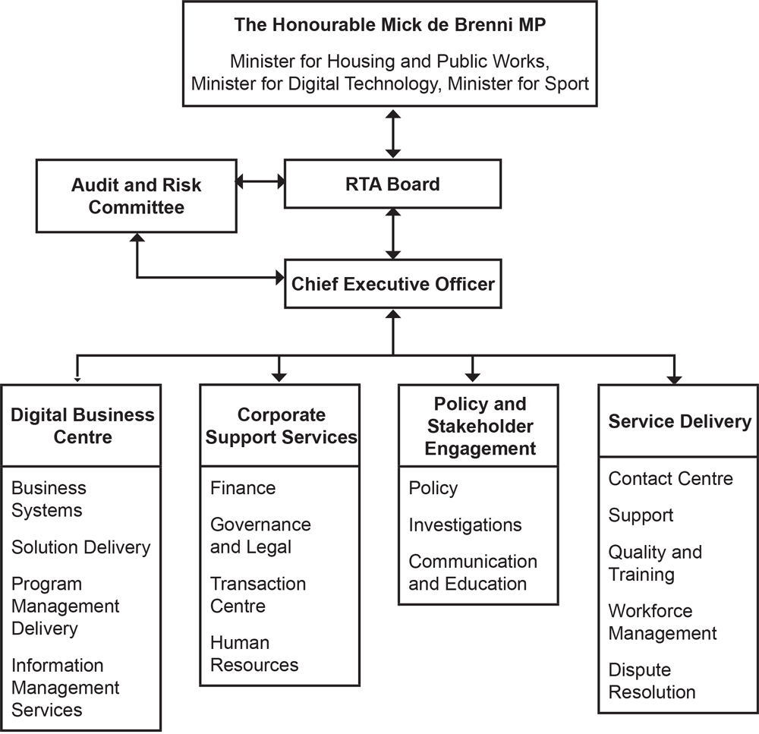

Image: RTA organisational structure flowchart

Board members

Steve Ryan
CertTeach, MAICD, MAIST
Director
Steve Ryan was appointed as a Director on 1 November 2016 and is also the Chair of the Audit and Risk Committee. Mr Ryan is an experienced Board member with over 40 years experience in strategic leadership, governance and service delivery. He has worked across the public, union, superannuation and not-for-profit sectors. Mr Ryan was Deputy Chairman of the Board of Directors and Board of Trustees at QSuper and a Board member of the Queensland Studies Authority’s Governing Body. He was president of the Queensland Teacher’s Union and was also also an executive member of the Australian Education Union and the Queensland Council of Unions.

Paul Melville
LLB, Solicitor
Chair
Paul Melville was appointed as a Director on 11 May 2017. He has over 15 years experience as a Director and Board member, currently working as joint Managing Director of Halcyon and a Board member of the Urban Development Institute of Australia.

Mr Melville has an extensive legal background, previously operating as a solicitor and senior partner within his own firm. He holds a Bachelor of Law from the Queensland University of Technology and was admitted as a Solicitor of the Supreme Court of Queensland.

Janet Benson
MA(Public Sector Policy and Leadership)
Director
Janet Benson was appointed as a Director on 11 May 2017. She is the former owner and principal of Bluemint Property Management and brings a comprehensive understanding of the Queensland property sector – in particular, residential property management. Ms Benson has a background in the Queensland public sector, working as the Executive Director of the Human Service CEO Committee, and Executive Director of Homelessness Programs at the Department of Housing and Public Works. She brings extensive knowledge of social housing, rental affordability and homelessness issues in Queensland. Ms Benson holds a Master of Arts (Public Sector Policy and Leadership) from Griffith University and is a licensed real estate agent in Queensland.

Christine Castley
BA, LLB, Postgrad Dip Arts, MPA
Director
Christine Castley has served in multiple senior leadership roles across the Queensland Government, with significant experience in strategic policy, governance and service delivery. She is currently Deputy Director-General in the Department of the Premier and Cabinet. Prior to this, Christine was Deputy Director-General, Housing, Homelessness and Sport in the Department of Housing and Public Works. In this role, Christine led major reform (including development of the Queensland Housing Strategy 2017–2027) and transformation of housing and homelessness services delivered by 1,500 staff, managing a $1.4 billion business and a $15 billion asset portfolio. Christine holds a Bachelor of Laws, Bachelor of Arts, Postgraduate Diploma of Arts and Master of Public Administration from the University of Queensland.

Rachel Watson
Director
Rachel Watson is a social worker with more than 20 years experience in the community services, local, state, commonwealth and not-for-profit sectors. Ms Watson brings extensive knowledge of transformational leadership, growth and innovation in the areas of homelessness, social inclusion, mental health and aged care.

Ms Watson is committed to quality service delivery with highly developed skills in creating cultures of accountability. Her diverse experience includes administration, governance, evaluation, engagement and policy writing.

Ms Watson is currently the Manager, Service Innovation and New Business at Wesley Mission Queensland and Chair of the Q Shelter Board of Management.

Sally Watson
BSocWk, MPubPolicy
Director
Sally Watson was appointed as a Director on 1 November 2016. Ms Watson has extensive experience in working in housing and homelessness services across the public and not-for-profit sectors. Based in Far North Queensland, Ms Watson is a lecturer in social work at James Cook University in Cairns. Previously, she was North Queensland Coordinator for the Tenants Union of Queensland and Executive Director of Homelessness Australia in Canberra. Ms Watson is Convenor of the Steering Committee of Tenants Queensland and a Board member of the North Queensland Women’s Legal Service.

Deborah Duffy
JP, Cdec, MAICD
Director
Deborah Duffy was appointed as a Director on 7 April 2010. Ms Duffy is a former Director of the Real Estate Institute of Queensland. She has more than 32 years experience in the real estate sector, winning numerous accolades including Property Manager of the Year. Ms Duffy bring a wealth of knowledge of Queensland's rental sector to the Board, particularly relating to housing issues in North Queensland.

Board Meetings

A total of 11 meetings of the RTA Board of Directors occurred during 2017–18:

Board Member | Number of attendances | Departure/Arrival
Catherine Sinclair (Chair) | 3/3 | 25 October 2017 was last Board meeting
Penny Gillespie | 3/3 | 25 October 2017 was last Board meeting
Deborah Duffy | 10/10 | Not a member for the meeting of 29 November 2017
Steve Ryan | 11/11 | Member for entire period
Janet Benson | 10/11 | Member for entire period
Sally Watson | 10/11 | Member for entire period
Paul Melville | 11/11 | Member for entire period
Rachel Watson | 7/7 | First Board meeting was 31 January 2018
Christine Castley | 7/7 | First Board meeting was 31 January 2018

Audit and Risk  Committee Member | Number of attendances | Departure/Arrival
Catherine Sinclair  (ex officio) | 1/1 | 23 August 2017 was last ARC meeting
Deborah Duffy | 2/2 | Ms Duffy was appointed as an ARC member at the Board meeting of 31 January 2018
Steve Ryan | 4/4 | Member for entire period
Janet Benson | 3/4 | Member for entire period
Sally Watson | 3/4 | Member for entire period
Paul Melville  (ex-officio) | 2/2 | Commenced attending ARC Meetings as ex officio member from 28 March 2018

Note: Caretaker government period
The Queensland Government election was called on 29 October 2017 and the government was claimed on 8 December 2017. Board positions that ended on 31 October 2017 during the caretaker period were:
- Catherine Sinclair’s appointment as Chair
- Penny Gillespie’s appointment as a Director
- Deborah Duffy’s appointment as a Director from 1 November 2016 to 31 October 2017

These positions could not be replaced during the caretaker period. The impact of the caretaker period was that the Board meeting of 29 November 2017 did not have an official Chair. The Board nominated Mr Steve Ryan as Acting Chair until the next meeting on 31 January 2018. Appointments commencing on 21 December 2017 were:
- Paul Melville as Chair
- Rachel Watson, Christine Castley and Deborah Duffy as Directors.

Accountability and risk management

Board Audit and Risk Committee

The Board’s Audit and Risk Committee (ARC) ensures the organisation’s objectives and strategies are achieved efficiently and effectively within an appropriate framework of internal control and risk management. The ARC Charter, reviewed annually, clearly defines the roles and responsibilities of its members. The ARC meets on a quarterly basis and includes Steve Ryan (ARC Chair), Deborah Duffy (Director), Janet Benson (Director), and Paul Melville (ex officio member/Chair). The CEO and Chief Financial Officer (CFO) report to this committee. The ARC oversees our accounting policies and practices, the integrity of financial statements and reports, the scope, quality and independence of external audit arrangements, the monitoring of the internal audit function, and the effectiveness of risk measures.

The ARC is also responsible for monitoring overall legal and regulatory financial compliance. The Internal Audit Strategic Plan 2017–2020, developed by ARC, maintains accountability, ensures compliance and identifies business processes to be audited each financial year. Internal and external auditors attend each ARC meeting. Achievements in 2017–18 were:

- Reviewed implementation of:
    - Internal Audit recommendations
    - External Audit recommendations
    - Risk register

The ARC adhered to the terms of its charter and the Queensland Treasury’s Audit Committee Guidelines.

Our Executive Leadership Team

Our Executive Leadership Team underwent considerable changes during the year due to departures by key members including Darren Barlow, Chief Executive Officer, John Rayfield, Chief Information Officer and Melanie Banner, Director Service Delivery. The official appointment of Jennifer Morgan to the role of Chief Executive Officer occurred on 30 April 2018.

The rebranding of the role of Chief Information Officer to Chief Digital Officer signified the focus of the role to lead the RTA forward in its digital offerings to the Queensland residential rental sector. Finalisation of the recruitment for this role occurred in June 2018 with the successful candidate being Nasa Walton. The other key executive role, Director Service Delivery, has Claudio Boveri acting in the position.

Jennifer Morgan
Chief Executive Officer
Jennifer has a broad range of management experience and leadership skills with demonstrated achievements in financial planning, corporate governance, policy development and the delivery of services across both private and public sectors.
Prior to joining the RTA, Jennifer held executive roles at Brisbane City Council. These roles included Assurance Delivery and Performance Manager, Financial Projects Manager and senior appointments within Corporate Treasury.

Jennifer holds a Bachelor of Business degree majoring in Accountancy from the Queensland University of Technology and is an accredited Workplace Executive Coach.

Juliet McKenzie
Chief Financial Officer
Juliet McKenzie leads the RTA’s Corporate Support Services including finance, bond transaction management, human resources, and legal and governance. From February 2018 to April 2018, she served as Acting Chief Executive Officer pending the arrival of our new CEO.

Juliet joined the RTA in November 2015 after 15 years in the water industry in executive and senior finance roles. She has extensive leadership experience in corporate services, developing commercial initiatives, governance and financial structures and policies during mergers, government restructuring and complex project management.

She has a Bachelor of Commerce from James Cook University and is a Fellow Certified Practising Accountant and Graduate of the Australian Institute of Company Directors.

Meghan Hibbert
Director, Policy and Stakeholder Engagement
Meghan leads our Policy and Stakeholder Engagement division’s research, consultation, investigations, communication and education services.

Meghan joined the RTA in July 2016 after more than 17 years experience in housing and community services, holding executive roles in government since 2008 and as general manager of a Tier 1 community housing provider. Her extensive experience includes policy development, ministerial liaison, change management, operations and asset management for the Queensland Department of Housing and Public Works and Housing NSW. Meghan’s comprehensive sector knowledge has led to her selection for a key project of the Queensland Housing Strategy 2017–2027.

She holds a Bachelor of Organisational Leadership and graduate qualifications in business management and social science (housing policy and management).

Claudio Boveri
A/Director, Service Delivery
Claudio Boveri leads the Service Delivery division, comprising the contact centre, dispute resolution and client support services offering personalised tenancy information.

Claudio joined the RTA in 2010 with several years experience in client service and management including roles with Queensland departments of Justice and Attorney-General and Transport and Main Roads. Before his Queensland Government experience, Claudio worked in the transport and logistics industry.

Having progressed through various roles in the Service Delivery division, Claudio has led key projects to enhance frontline services and, as Workforce Manager, developed robust processes to maximise resources.

He has a Bachelor of International Business from University of the Sunshine Coast and is a qualified Prince2 Practitioner.

Nasa Walton
Chief Digital Officer
Nasa is an award winning Chief Information Officer with a career in delivering innovative solutions. As the CIO of a hospital and health service for the past five years, she also has experience in other health industry senior leadership. Appointed in June 2018 and commencing in July as Chief Digital Officer, Nasa guides our ICT strategic direction and leads the Digital Business Centre (DBC), comprising helpdesk and application support, innovative projects, business intelligence, information management and clients’ online communication and forms lodgement.

Nasa has a Bachelor of Business, Human Resource Management, from Southern Cross University and a Graduate Certificate in Marketing and Communications from Canberra University.

Our corporate governance framework

The RTA bases its corporate governance framework on the Queensland Treasury Corporate Governance Guidelines for Government Owned Corporations and the Queensland Auditor-General’s model and includes far-reaching accountability processes. Our commitment to the Queensland Government’s focus on integrity and accountability underpins our existing corporate governance processes.

Good governance
Performance
- improve results through effective use of performance information
- improve delivery of services through efficient and effective use of resources
- enhance client service through innovative business processes and continuous improvement.

Accountability
- fulfil obligations and legislative requirements in the best interests of our stakeholders and the sector
- ensure confidence in our decisions and actions through our own standards, policies and procedures, roles and responsibilities
- act impartially and ethically to meet community expectations of integrity, transparency and openness.

Good governance elements

- Continual improvement – enhanced business processes using a cycle of continuous improvement to improve organisational effectiveness and efficiencies
- Risk management – regularly assess and respond to risks by linking everyday processes and practices to operational and strategic risk
- Leadership and strategy – shared understanding of our vision, purpose, priorities through effective planning, collaboration and resource allocation
- Alignment – functions, structures and culture that support our organisational goals through role clarity and empowered staff
- Responsibilities – accountability, transparency for decisions through legislative compliance and corporate reporting
- Performance management and evaluation – building a high performing culture through agreed performance expectations, effective communication, best practice management and capability building
- Ethical standards and values – acting impartially and ethically in the interests of the RTA, adhering to the Code of Conduct and our values are reflected in our behaviour.
- Systems and processes – accountable and transparent decision making processes, robust internal control mechanisms, compliance, policies and procedures
- Deliver – quality client service, stakeholder engagement, collaboration, monitoring, review and reporting

Governance practices, strategies, policies, processes and resources that provide confidence to our stakeholders and the sector.

 | 1 | 2 | 3 | 4 | 5 | 6 | 7 | 8 | 9
Residential Tenancies and Rooming Accommodation Act (2008) and Acts Interpretations Act (Qld) 1954 | • |  |  | • | • |  |  | • | •
Strategic Plan | • | • | • | • | • | • | • | • | •
Annual Report | • | • | • | • | • | • | • | • | •
State Budget |  |  | • | • | • | • |  |  | •
Statutory Bodies and Financial Arrangements Act 1982 |  |  |  | • | • | • |  | • | •
Financial Accountability Act 2009 and Financial Management Standard 2009 |  | • | • |  | • | • |  | •
2020 Business Plan | • | • | • | • | • | • | • | • | •
Annual Business Plan |  | • | • | • | • | • | • | • | •
Divisional Operational Plans |  | • | • | • | • | • | • | • | •
Organisational Structure | • |  |  | • | • |  |  |  | •
Position Descriptions | • |  | • | • | • | • | • |  | •
Induction Strategy |  | • |  | • | • | • | • | • | •
Mandatory Training | • | • | • | • | • | • | • |  | •
Delegations of Authority including associated policies, procedure  and register |  | • |  | • | • |  | • | •
Ministerial Charter Letters |  | • | • |  | • | •
Queensland Housing Strategy 2017–2027 | • | • | • | • | • |  |  | • | •
Public Sector Ethics Act 1994 |  | • |  |  | • | • | •
Anti-Discrimination Act 1991 (Qld) |  | • |  |  | • |  | • | •
Information Privacy Act 2009 (Qld) |  | • |  |  | • | • |  | •
Right to Information Act 2009 (Qld) |  | • |  |  | • | • |  | •
Public Interest Disclosure Act 2010 (Qld) |  | • |  |  | • | • | • | •
Code of Conduct |  | • |  | • | • |  | • | • | •
Quality Management including Work Instruction Working Group | • | • |  |  | • |  |  | • | •
Performance Management Planner Schedule of Corporate Governance Activities |  | • | • | • | • | • | • | • | •
Quality Monitoring Program | • | • |  |  | • |  |  | • | •
Procurement Strategy |  | • |  |  | • |  | • | •
Digital Strategy | • | • |  |  | • | • |  |  | •
Post-Call Client Surveys | • | • |  |  | • |  |  | • | •
Outreach Program | • |  |  |  |  |  | • | • | •
Industry Development Forum | • |  | • |  |  |  | • | • | •
Client Service Charter | • | • |  |  | • | • | • | • | •
Policies, Procedures and Work Instructions |  | • |  | • | • | • |  | • | •
Risk Management Framework | • | • | • |  | • |  |  | •
Strategic Risk Register | • | • |  |  | • |  |  | • | •
Legislative Compliance Register | • | • |  |  | • |  |  | • | •
Business Continuity Management Plans |  | • |  |  | • |  |  | • | •
Performance Management Framework |  |  |  | • |  | • | • | • | •
Competency Framework | • |  |  | • |  |  | • |  | •
Learning and Development Strategy | • |  |  | • |  |  | • |  | •
Work Health and Safety Plan |  | • |  |  | • |  | • |  | •
Quality and Training Program |  | • |  | • |  |  | • | • | •
Project and Program Governance Model | • | • | • |  | • |  |  | • | •
RTA Brand Policy including Style Manual and Associated Guides |  | • |  |  |  |  |  | • | •
Financial Management Practices Manual |  | • |  |  | • |  |  | • | •
Open Data Strategy |  | • |  |  |  |  | • | • | •
Working for Queensland Survey Results and Action Plans | • | • | • |  |  |  | •
Red Flag Escalation Process | • | • |  | • | • | • | • |  | •
External Reviews | • | • |  |  | • | • |  |  | •

External scrutiny

During the year, the RTA engaged a number of external experts to review and provide feedback on systems, processes, polices and strategies.

These reviews included –
- KPMG – Payroll system implementation assurance
- Price Waterhouse Coopers (PwC) – Payroll project assurance
- Deloittes – Review of the business intelligence strategy
- Protiviti – Internal Controls Review

Further to these, Crowe Horwath was engaged to undertake a wide range of internal audit programs. For these include:
- Procure to Pay
- Payroll Processing
- Business Continuity Planning
- System Change Management
- Investigations Management
- IT Security

The RTA engaged Pitcher Partners through the Queensland Audit Office to provide annual financial audit services. No significant findings have been reported through the reviews.

Internal audit

Internal accountability processes include planning mechanisms for the management of risk and the associated internal audit function, the flow of information to and from the Executive Leadership Team, and engagement with stakeholders. The internal audit assists with our strategic goals by providing an independent review of identified areas. The reviews assist with:

- reliability and integrity of financial and other operating information
- adequacy and effectiveness of systems and controls
- compliance with policies, laws and regulations
- prevention of fraud and corruption
- safeguarding of assets
- risk management planning
- economic and efficient use of resources

Committees and groups

- The Consultative Committee (CC) provides a forum to discuss and consult on staff relations including industrial relations and ensures issues are managed appropriately. The committee meets quarterly and as issues arise.
- The Portfolio Management Steering Committee (PMSC) is chaired by the CEO and includes senior management and an external representative. It ensures corporate projects operate efficiently and effectively and are sufficiently resourced to support our business and corporate needs.

Public interest disclosure

All of our staff members have an ethical responsibility to report actual, or suspected, instances of official misconduct as defined in the Public Interest Disclosure Act 2010. There were no disclosures this financial year.

Ethical standards

The RTA Code of Conduct provides a framework for ethical conduct based on the principles and values of the Public Sector Ethics Act 1994. All staff must carry out their duties with integrity and impartiality, be accountable and transparent, and promote the public good. All staff have completed mandatory Code of Conduct training using the online management system myPlace. The code is also reflected in all of our Human Resources policies, procedures and initiatives.

Positive client feedback

The RTA values the opinions of our clients and actively encourages feedback about our services. Feedback options are embedded in all channels of communication. Organisation-wide feedback is overwhelmingly positive and reflects the success of the RTA’s client focused culture.

In 2017–18, the RTA’s website was updated to make it easier for clients to submit a complaint or make a suggestion. We responded to 136 formal client complaints in 2017–18 (179 in 2016–17, a 24 per cent decrease). In addition to the reduction in complaints, client satisfaction surveys demonstrated a 7.3 per cent increase in overall client satisfaction from Q4 2016–17 to Q4 2017–18.

Performance review framework

The RTA Board and CEO are responsible for monitoring and reviewing the performance of the organisation. The performance review framework ensures this role is undertaken with comprehensive knowledge of our functions.

The table below outlines our 2017–18 performance against the key elements of the framework.

Function | Purpose | Achievements 2017–18
Monthly financial reporting | Reports level of revenue and expenditure against the approved budget at each Board meeting | Comprehensive monthly financial reports provided at each Board meeting
Performance measures | Reports achievement against annual performance targets. These targets include the number of enquiries, the quality of information provided and timeliness of the response | Full performance reports provided at each Board meeting
Internal audit program | Reports progress and recommendations from internal audit to the ARC | Full status of all audits provided to the ARC – no critical level risks
Service Delivery Statement | Contributes to the Minister’s report on performance and budget results to the Queensland Parliament | Effective investment management resulted in stronger returns outperforming the budgeted target
Annual Report | High reporting standards ensure accountability to the RTA’s clients, sector and staff | Full compliance with the Queensland Government’s annual reporting requirements

Business and financial planning

The Board sets the organisation’s strategic direction, which is documented and formalised through the RTA Strategic Plan 2017–21 (visit rta.qld.gov.au to access a copy).

The 2017–21 Strategic Plan identifies priorities relating to enhanced client service, lean systems, adaptive people and business sustainability.

The strategic plan is underpinned by an annual business plan and divisional operational plans specifying activities and performance levels to be achieved. Staff complete annual performance development plans with their line managers to identify their contribution to planning and performance and to determine their professional development requirements. Our business planning is used to develop our budget, which is endorsed by the Board and approved by the Minister. We report to public stakeholders through the Annual Report, annual Service Delivery Statements and Parliamentary Estimates Hearings process.

Recordkeeping and access to information

Recordkeeping
The Public Records Act 2002 governs RTA’s records management. The Records Management Unit maintains centralised control and oversees the records management framework. The RTA has policies and procedures in place, including a Records Management Policy, to inform staff of all aspects of recordkeeping practices and responsibilities. Our Business Classification Policy, Disposal of Records Policy and Vital Records Policy also support compliance with Information Standard: 40 Recordkeeping (IS40) and Information Standard: 31 Retention and disposal of public records (IS31). A phased implementation of RTA’s new SharePoint and RecordPoint Electronic Document and Records Management System (eDRMS) is currently in progress. The new eDRMS has been successfully implemented in pilot areas. Full implementation across all business areas is planned for 2018–19.

Right to information

The Right to Information Act 2009 (RTI Act) allows members of the public access to certain information controlled by the Queensland Government. The RTA supports right to information principles by operating in an open, transparent and accountable manner while protecting the privacy of clients and staff. In 2017–18, the RTA responded to two applications for access to documents relating to bonds and disputes under the RTI Act.

The RTA’s Administrative Access Policy allows public access to certain types of information held by the RTA without having to apply through the formal RTI Act or the Information Privacy Act 2009 (IP Act) application processes.

Where possible, the RTA will release information under this policy. In 2017–18, the RTA responded to 953 requests made under the Administrative Access Policy.

Information privacy

The Information Privacy Act 2009 (Qld) gives members of the public the legal right to access and amend their personal information. It requires the RTA to safeguard personal information it holds and disclosures can occur only when the individual it relates to provides consent or where it is required and authorised under law. In 2017–18, the RTA received nine applications from individuals for access to documents containing their personal information.

Information systems and cyber security

In 2017–18, we continued to enhance the management and security of our information assets. Key initiatives included:
- moving some services to the cloud and planned for further migration of infrastructure to a scalable, on-demand cloud delivery model
- strengthening of the RTA’s IT security posture through a range of initiatives including changes to user access requirements and a review of the security access matrix for the core myRTA system
- finalising implementation of an enterprise content management system and commenced work on implementation of an electronic records management system
- commencing work on data quality improvement initiatives and developing business intelligence reporting dashboards to enhance data quality processes and ensure data integrity and completeness for all business critical datasets

Open data – access and content

The RTA meets its requirements to publish information through the Queensland Government’s Open Data portal at http://data.qld.gov.au. Information published includes:
- Consultancies
- Overseas travel
- Queensland Language Services Policy

Our people

Our people are the key to our success and the RTA has put enormous energy into building an adaptive workforce during a time of significant organisational change.

This focus, which is an important pillar of the organisation’s strategic plan, is helping to build the foundations of a high performance culture.

Learning and development strategy

The Learning and Development Strategy, a major RTA initiative in 2016–17, was developed and implemented to achieve that goal. This two-year strategy and its associated initiatives will be reviewed and evaluated at the cessation of the year to enable a further strategy to be developed for the following year.

The current strategy includes:
- enhancing capability to improve performance and productivity
- adopting modern and best practice approaches in the sector
- minimising organisational and operational risk
- enhancing organisational performance

Other strategic initiatives include:
- talent and succession management
- reward and recognition
- myPlace online learning management system
- new performance framework

Talent and succession management plan

This plan identifies staff members with ability, potential and passion to move into senior roles in the RTA.

The RTA’s framework was built to:
- develop leadership pathways to ensure business continuity
- resource talent development to ensure a greater return on investment
- identify and deploy the best candidates for key positions
- develop critical technical capability
- develop potential successors

Succession planning has occurred for all critical roles across the RTA, as well as talent assessment across the executive and leadership teams.

Reward and recognition program

This program recognises and rewards staff who help build a high performance culture at the RTA. The current reward and recognition program addresses the Working for Queensland survey results across a range of areas such as engagement, learning and development, recognition and performance and aligns itself with the RTA performance framework.

myPlace online learning management system

The RTA undertakes a blended approach to learning following the 70:20:10 rule. Part of this learning approach is the use of the online learning management system (named myPlace).

The learning management system is web based and allows staff 24/7 access to training modules on PCs, smartphones and tablets and replaces the more traditional and costly face-to-face approach. The system streamlines metrics and reporting and helps mitigate risk by ensuring staff complete mandatory training in areas such as code of conduct, work health and safety and other compliance areas.

The myPlace platform is powered through ELMO and is also utilised for our performance module.

Driving a high performing culture

The RTA implemented a performance framework on 1 July 2017, which aims to help create a high performing organisation and supports and enables the RTA’s strategic objectives to be met. The framework encourages all employees to support and participate in a high performance environment and encourages a learning and growth culture.The Public Service Commission’s competency framework (Success Factors) outlines expectation of behaviour in the workplace and helps enable career path planning and the transfer of skills across the Queensland Public Sector.

The performance framework will be hosted in myPlace to enable streamlined tracking, reporting, intelligence gathering and forward planning, delivering on our strategic goal of developing lean systems.

In order to support a high performing culture, 360-degree feedback has been rolled out to all of the RTA leadership team. This feedback then forms part of their development needs and assists in the formulation of the RTA training calendar and leadership development programs.

Safety and employee wellbeing remains a priority

In 2017–18, 16 workplace incidents occurred without any lost time due to injury. All legislative and reporting requirements were met including those to regulatory bodies. We also supported a number of employees through rehabilitation programs to facilitate a safe return to the workplace after a significant absence or injury.

A Work Health and Safety Strategic Plan was developed and implemented in 2017–18 and approved by the RTA Board. This initiative has progressed well against the plan and focused on two primary areas of ergonomics and managing mental health in the workplace.

The Wellness Program gave staff the opportunity to increase their knowledge of health issues through annual health assessments, skin cancer checks and the flu vaccination program. We also leveraged our corporate partnerships with healthcare providers, Medibank Private and Bupa through a series of sessions for staff. This included information on healthy eating habits, dealing with stress and anxiety, and general mental health matters. As well, financial information sessions, conducted by Q Super, Remserv and Smart Salary were integrated into the program.

Our free, confidential counselling and online service for staff have proven popular during the year. The Employee Assistance Program, Benestar, has been well utilised by staff over the last year.

Promoting equity at work

We promote a discrimination-free workplace by educating staff about anti-discrimination laws through formal induction training, brochures and pamphlets, and information on the intranet.

The RTA supports Equality of Employment Opportunity (EEO) events such as Mental Health Week, International Women’s Day and Domestic Family Violence Prevention Month. Requirements and principles for EEO and anti-discrimination are incorporated into RTA policies, procedures and training.

The RTA also celebrated other events for the first time such as Brisbane Pride and White Ribbon Day.

The RTA supports people within the workplace who may be making changes within their personal life such as gender transitioning.

Healthy work-life balance

The RTA continued to encourage staff to maintain a healthy work-life balance by providing flexible accrued time, part-time employment, casual employment and formal working from home arrangements.

The Queensland Public Service Officers and Other Employees’ Award – State 2015 allows for greater flexibility for staff with additions such as the ability to use recreation leave and long service leave on half pay or take recreation leave as a part day.

With the introduction of more efficient technologies and ways of doing business, the RTA has piloted a variety of flexible workplace options being utilised across different areas of the business. This allows the RTA to retain highly talented and capable people, whilst they are supporting family commitments.

Our workforce is the key to our success

Our workforce is critical in the achievement of the deliverables of the RTA strategy.

High staff retention continued in 2017–18 and, as at 30 June 2018, 65 employees recorded 10 or more years of service with our organisation, representing 26.75 per cent of our workforce.

Of these, 11 employees (four per cent of the workforce) completed 15 or more years of service, a further 11 employees completed 20 or more years of service and six employees (two per cent of the workforce) had completed 25 or more years of service.

The annual separation rate for 2017–18 was 21.5 per cent of the workforce. This rate includes staff who resigned to take up roles elsewhere in the public service. During the period, one employee received a redundancy package at a cost of $93,510.

Workforce profile

Employees (FTE) by division*
as at 30 June 2018

Office of the CEO | 2
Policy and Stakeholder Engagement | 21.40
Corporate Support Services | 74
Digital Business Centre | 14.76
Service Delivery | 95.59
Total | 207.75

Employees (headcount) by occupation and gender *
as at 30 June 2018

Occupation | Female | Male
Managers and administrators | 6 | 5
Professionals | 21 | 12
Clerical and administrative workers | 126 | 60
Total | 153 | 77

*Note: This table does not include employees on extended leave or contract and temporary agency staff.

RTA support for community

RTA staff raised over $7,200 for homeless charities

For over a decade, RTA staff have made a difference to the lives of Brisbane’s homeless and disadvantaged by collecting gold coin donations every Friday for two worthy charities.

We remain committed to our favourite charities, the Ecumenical Coffee Brigade (ECB) and the Brisbane Youth Service (BYS), who help the homeless. During 2017–18, we raised $7,200 for these charities.

RTA recycling restores hope for the homeless

When the time came to dispose of old computer hardware, the RTA found a way to support both the environment and the community.

In a major update of our information technology this year, we disposed of hundreds of PCs, servers, monitors, printers, toner cartridges, routers, phones, keyboards, mice and scanners.

Buyequip, a social enterprise established in 2001 to divert electronic waste from landfill and securely dispose of old data, assisted us with removing the old equipment.

More than 500 assorted items were collected by Buyequip to be redeployed, upcycled, recycled or dismantled for parts.

Importantly, Buyequip provides opportunities for vulnerable, isolated and homeless people to earn an income while gaining transferrable skills and real life training.

Our Finances

Key results

- 3.0% return on investment
- $855.58M value of bonds held
- -$7.89M operating deficit
- Focus on reducing transaction costs

Future priorities

- Business sustainability
- Customised, near real-time information for staff and stakeholders

Financial overview

Lower investment returns with strong expense control

This financial year saw investment returns moderately drop below forecasted results with investment income below budget by $1.5m. Offsetting this return was the RTA’s ability to reduce expenses under the budgeted number by $1.0m.

Investment returns totalled $26.0m in 2017–18. The average rate of return on investments of rental bonds was 3.0 per cent against a budgeted return of 3.2 per cent. This is a further decrease from 4.4 per cent in 2016–17 due to widening credit spreads impacting bond yields and continuing low interest rates in Australia.

We are committed to ensuring prudent management of investments through agreed strategies and processes in line with the Statutory Bodies Financial Arrangements Act 1982. Given continued market uncertainty, we are working closely with our fund manager, Queensland Investment Corporation (QIC) to ensure investment risks are carefully managed.

Expenses decreased from $34.3m in 2016–17 to $34.0m in 2017–18 and further savings initiatives kept costs below the 2017–18 budget by $1.0m. Overall this resulted in an operating deficit of $7.9m.

Financial position

Despite weaker investment returns, the RTA continued to maintain a healthy balance sheet, with no debt and a high level of liquid assets. Total equity decreased from $43.5m in 2016–17 to $35.6m, due to the deficit of $7.9m. The value of bonds held during 2017–18 increased by 5.0 per cent from $815.5m to $855.6m.

Financial performance
2012–13 to 2017–18

Financial year | Income | Expenditure | Surplus/deficit
2012–13 | 45.72 | 41.06 | 4.66
2013–14 | 46.69 | 48.66 | (1.98)
2014–15 | 24.54 | 34.55 | (10.01)
2015–16 | 27.42 | 37.20 | (9.78)
2016–17 | 34.99 | 34.27 | 0.72
2017–18 | 26.09 | 33.98 | (7.89)

Financial performance

The table above gives a snapshot of our financial performance and highlights the relationship between the level of investment revenue, expenditure and the surplus or deficit achieved for the last six years. The year’s operating deficit of $7.9m is due to actual investment returns underperforming against forecast. Investment returns were below expectations at 3.0 per cent compared with 4.4 per cent in the previous year. The result of this reduced return was that income was $1.5m below budget and $8.9m lower than 2016–17.

Costs continued to be managed during the year and annual costs were contained to $1.0m below budget. During 2017–18, the RTA wrote down the value of the work in progress intangible asset relating to software development of the bond management system’s outdated portal module. The write down occurred due to the additional costs required for the implementation of the portal. The costs do not outweigh the benefit of a potential new solution to adapt to the increasing pace of new technologies. The effect of the write down was an extra $1.1m recognised in the final results for 2017–18. Despite this, write down expenses were still $0.3m below 2016–17 expenditure.

The operating deficit is funded from our accumulated surplus. This reserve ensures that service delivery will continue at current or increased levels into the future without disruption.

Investment management

We manage our investments in accordance with Part 3, Division 5 of the Residential Tenancies and Rooming Accommodation Act 2008 and with the Statutory Bodies Financial Arrangements Act 1982.

Earnings from the investment of rental bonds are allocated between the rental bond portfolio and the business operations portfolio. The rental bond portfolio represents the investment of all rental bonds held. It is actively managed predominantly by fund manager QIC and funds are allocated across a range of asset classes according to the investment strategy adopted by the RTA Board. The RTA has also allocated investment funds to the Queensland Treasury Corporation (QTC).

The business operations portfolio represents the earnings from investments and is used to fund all RTA business operating expenses and grants.

Allocation of investment funds
as at 30 June 2018

Fund type | Investment range | Amount invested  ($’m) | Allocation QIC | Allocation QIC/QTC/other
QIC Bond Plus Fund | 0–45% | 163.7 | 19.5%
QIC Cash Enhanced Fund | 0–100% | 184.6 | 21.2%
QIC Global Credit Fund | 0–45% | 336.3 | 40.0%
QIC Global Credit Opportunities Fund | 0–20% | 1.7 | 0.2%
QIC Property Fund | 0–20% | 155.6 | 18.3%
Total QIC |  | 841.9 | 100% | 96.2%
QTC |  | 31.7 |  | 3.6%
Other |  | 1.7 |  | 0.2%
Total funds invested |  | 875.3 |  | 100%

Operating Income

The RTA’s income relies almost exclusively on investment income from the investment of the rental bond portfolio. Revenue from investments fell 25 per cent from 2016–17 results and 44 per cent from the revenue earned in 2013–14.

As a result of these reductions in income, the RTA, in conjunction with QIC, actively managed the investment portfolio to receive the maximum return possible, without exposure to additional risk, while staying within investment guidelines and existing approvals. Steps that were taken include increasing the investment into the QIC Property Fund, which returned 8.9 per cent for 2017–18, and holding onto cash assets while they equalled or outperformed other investment types. The retention of cash gives the RTA the flexibility to invest as opportunities arise, such as the additional investment in the QIC Property Fund.

Operating expenditure

Overall expenditure decreased by $0.3m (0.8 per cent) to $34.0m. This expenditure result includes the write down of the intangible assets value by $1.1m. This write down has occurred as a one-off adjustment to the RTA’s software assets.

Total expenditure by type

Expenditure | 2016–17 |  | 2017–18
Salaries and related expenses | $20.9m | 61% | $20.4m | 60%
Supplies and services | $11.7m | 34% | $10.6m | 31%
Other expenses | $1.7m | 5% | $3.0m | 9%
Total | $34.3m | 100% | $34.0m | 100%

Employee expenses

Employee expenses represent approximately 60 per cent of our total expenditure. In 2017–18 we were able to decrease employee expenses by $0.5m (-2.4 per cent) from $20.9m in 2016–17 to $20.4 in 2017–18. This reduction is due to the return to business as usual activities after the completion of major projects in 2016–17.

Supplies and services

Supplies and services decreased by $1.1m (-9.4 per cent) from $11.7m in 2016–17 to $10.6m in 2017–18 due to cost savings initiatives and completion of major project work. Savings were gained through a range of spending reductions including reduced postage and mail house costs as a result of increasing online services engagement, decreased telecommunications costs and reduced information technology spending. These savings initiatives begin to support the RTA to achieve an economically sustainable business model that can service Queenslanders well into the future.

Other expenses

The RTA’s other expenses include depreciation and amortisation expenses. Due to the write down of intangible assets the proportion of the other expenses has increased in 2017–18 to 8.6 per cent compared to 2016–17 at 4.9 per cent.

Improved efficiency reduces costs

The RTA continues to focus on reducing transaction costs through the increasing use of automation and enabling clients to self-service.

Management certificate

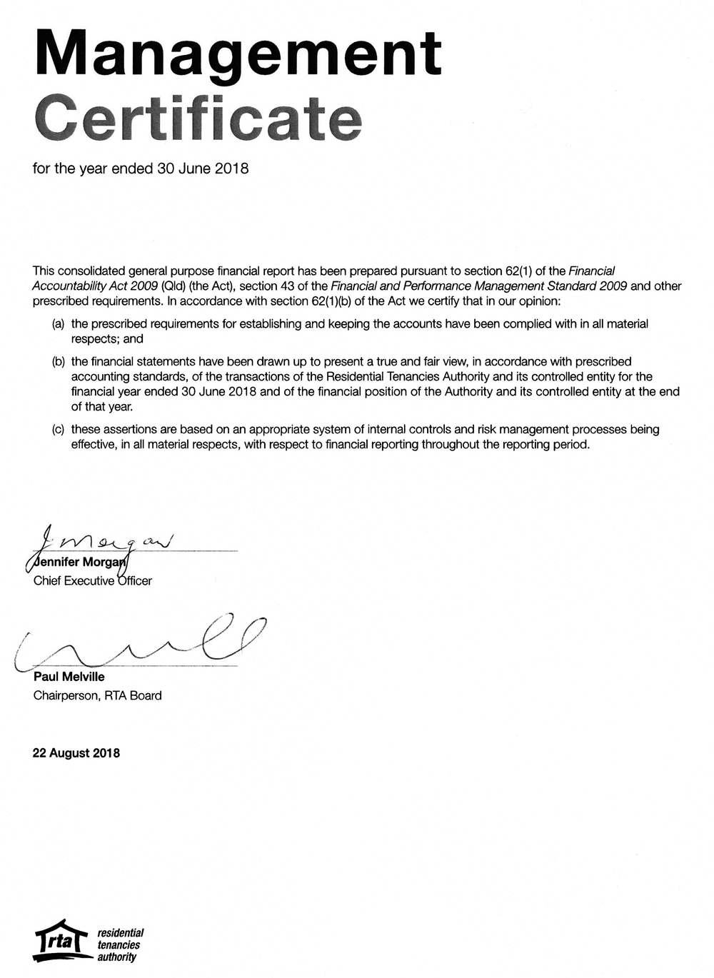

Image: Management certificate.
Independent auditor’s report

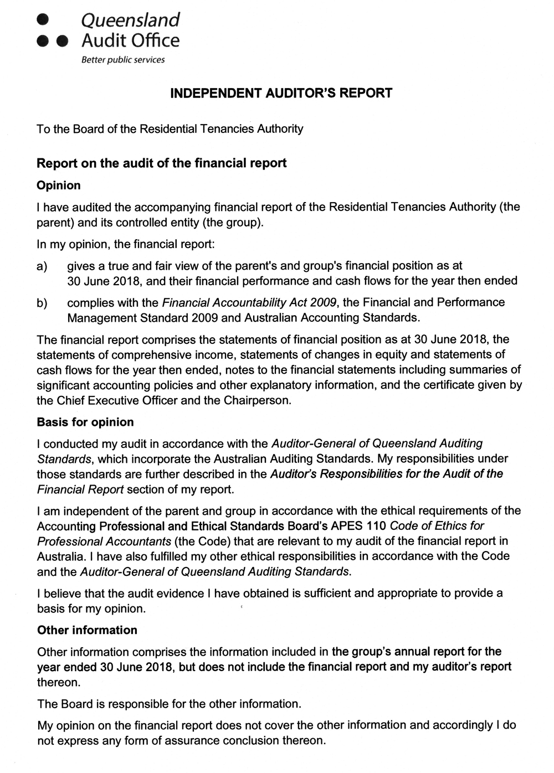

Images: Independent Auditors report page 1
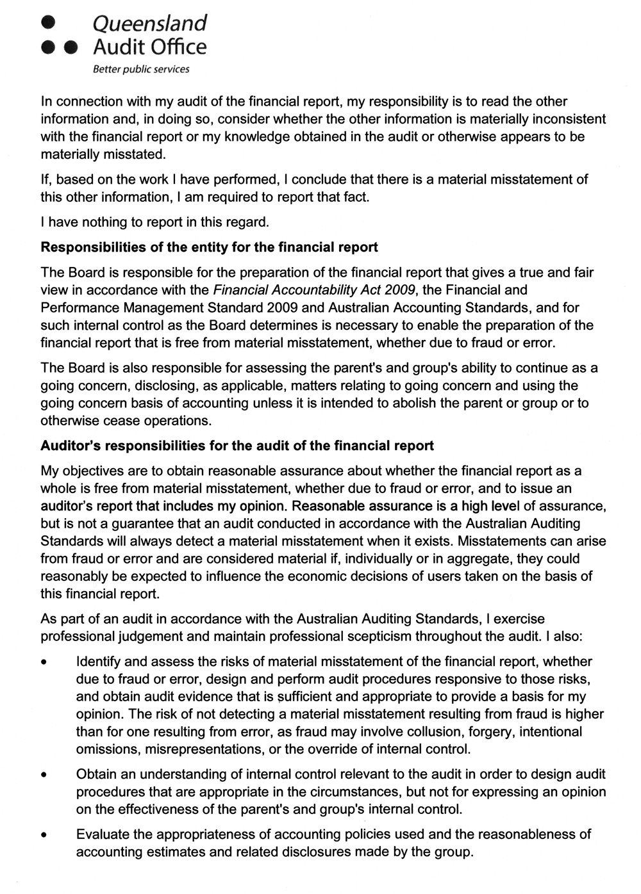

Images: Independent Auditors report page 2
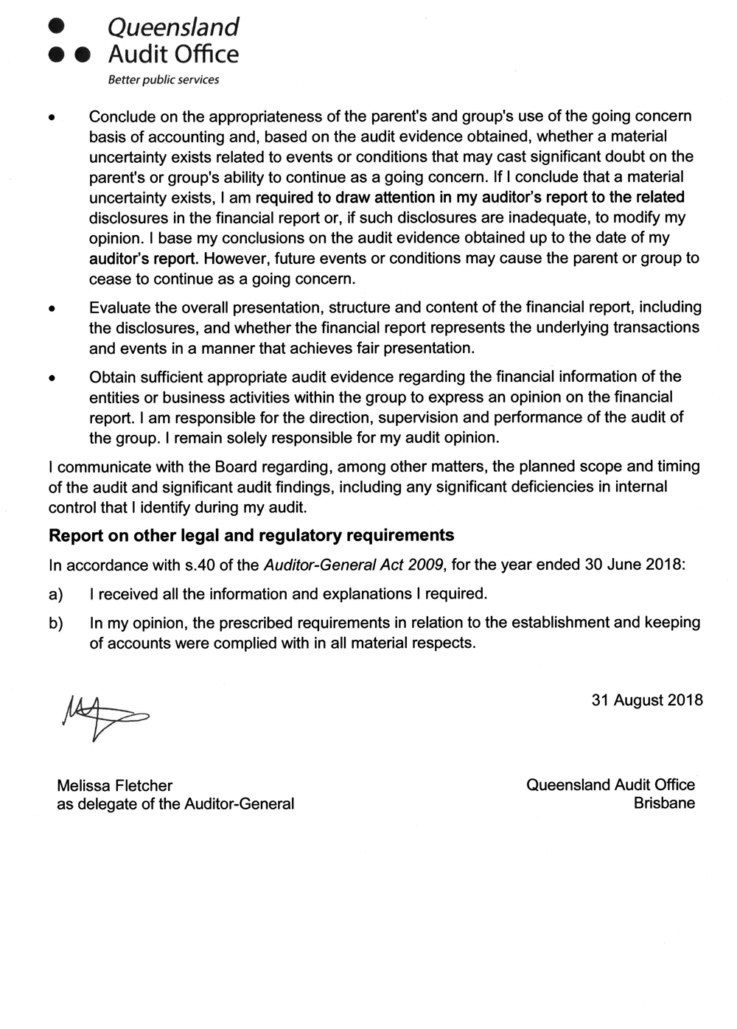

Images: Independent Auditors report page 3
Glossary – acronyms and abbreviations

ARAMA Australian Resident Accommodation Managers Association
ARC Audit and Risk Committee
BYS Brisbane Youth Service
CALD Culturally and Linguistically Diverse
CC Consultative Committee
CPAQ Caravan Parks Association of Queensland
DBC Digital Business Centre
DPC Department of the Premier and Cabinet
DHPW Department of Housing and Public Works
DJAG Department of Justice and Attorney-General
eDRMS Electronic Document and Records Management System
ECB Ecumenical Coffee Brigade
EEO Equal Employment Opportunity
FPMS Financial and Performance Management Standard 2009
FTE Full­time Equivalent (staff)
IAP2 International Association for Public Participation
IDF Industry Development Forum
IP Act Information Privacy Act 2009
NAIDOC National Aboriginal and Islanders Day Observance Committee
OFT Office of Fair Trading
PMSC Portfolio Management Steering Committee
POAQ Property Owners Association of Queensland
QCAT Queensland Civil and Administrative Tribunal
QFES Queensland Fire and Emergency Services
QIC Queensland Investment Corporation
QPS Queensland Police Service
Q Shelter Queensland Shelter
QSTARS Queensland Statewide Tenant Advice and Referral Service
QTC Queensland Treasury Corporation
REIA Real Estate Institute of Australia
REIQ Real Estate Institute of Queensland
RTA Residential Tenancies Authority
RTEO Residential Tenancies Employing Office
RTI Act Right to Information Act 2009
RTRA Act Residential Tenancies and Rooming Accommodation Act 2008
SDS Service Delivery Statement
TAFE Technical and Further Education
TIS Translating and Interpreting Service
TQ Tenants Queensland

List of tables

2017–18 Snapshot 13
Actual results for 2017–18 24
Adaptive people 20
Allocation of investment funds as at 30 June 2018 54
Board Meetings 39
Bond forms processed 30
Bond management 29
Business sustainability 20
Calls Answered by RTA’s Contact Centre 27
Dispute resolution requests received 27
Enhanced client service 16
Finalised investigations into non-compliance with the Act 34
Financial performance 2012–13 to 2017–18 53
Governance practices, strategies, policies, processes and resources
that provide confidence to our stakeholders and the sector. 43
Lean systems 17
Median length of tenancies (months) 13
Median rents for Queensland and major centres 14
Our clients 11
Our corporate governance framework 43
Our operating environment 10
Our organisational structure 36
Performance review framework 46
Queensland bonds held by the RTA 14
Reasons for disputes 29
RTA Service Delivery Statement 23
Total bonds held by dwelling type 15
Total expenditure by type 54
Types of offences investigated in 2017–18 34
Weekly median rents 13
Workforce profile 50

Compliance checklist

Summary of requirement |  | Basis for requirement | Annual report page reference
Letter of compliance | A letter of compliance from the accountable officer or statutory body to the relevant Minister/s | ARRs – section 7 | 4
Accessibility | Table of contents | ARRs – section 9.1 | 3
 | Glossary |  | 60
 | Public availability | ARRs – section 9.2 | 2
 | Interpreter service statement | Queensland Government Language Services Policy  ARRs – section 9.3 | 2
 | Copyright notice | Copyright Act 1968  ARRs – section 9.4 | 2
 | Information licensing | QGEA – Information Licensing  ARRs – section 9.5 | 2
General information | Introductory information | ARRs – section 10.1 | 5
 | Agency role and main functions | ARRs – section 10.2 | 5
 | Machinery of Government changes | ARRs – section 31 and 32 | n/a
 | Operating environment | ARRs – section 10.3 | 10
Non-financial performance | Government’s objectives for the community | ARRs – section 11.1 | 20-21
 | Other whole-of-government plans/specific initiatives | ARRs – section 11.2 | 21-22
 | Agency objectives and performance indicators | ARRs – section 11.3 | 16–20
 | Agency service areas and service standards | ARRs – section 11.4 | 22-24
Financial performance | Summary of financial performance | ARRs – section 12.1 | 52-55
Governance – management and structure | Organisational structure | ARRs – section 13.1 | 36
 | Executive management | ARRs – section 13.2 | 40-41
 | Government bodies (statutory bodies and other entities) | ARRs – section 13.3 | n/a
 | Public Sector Ethics Act 1994 | Public Sector Ethics Act 1994  ARRs – section 13.4 | 45
 | Queensland public sector values | ARRs – section 13.5 | n/a
Governance – risk management and accountability | Risk management | ARRs – section 14.1 | 40, 42
 | Audit committee | ARRs – section 14.2 | 40, 46
 | Internal audit | ARRs – section 14.3 | 40, 44, 46
 | External scrutiny | ARRs – section 14.4 | 44
 | Information systems and recordkeeping | ARRs – section 14.5 | 46-47
Governance – human resources | Strategic workforce planning and performance | ARRs – section 15.1 | 48-49
 | Early retirement, redundancy and retrenchment | Directive No.11/12 Early Retirement, Redundancy and Retrenchment  Directive No.16/16 Early Retirement, Redundancy and Retrenchment (from 20 May 2016)  ARRs – section 15.2 | 50
Open Data | Statement advising publication of information | ARRs – section 16 | 47
 | Consultancies | ARRs – section 33.1 | 47
 | Overseas travel | ARRs – section 33.2 | 47
 | Queensland Language Services Policy | ARRs – section 33.3 | 47
Financial statements | Certification of financial statements | FAA – section 62  FPMS – sections 42, 43 and 50  ARRs – section 17.1 | 56
 | Independent Auditor’s Report | FAA – section 62  FPMS – section 50  ARRs – section 17.2 | 57-59

FAA Financial Accountability Act 2009
FPMS Financial and Performance Management Standard 2009
ARRs Annual report requirements for Queensland Government agencies

Contact the RTA

Level 23, 179 Turbot Street
Brisbane Q 4000

Phone: 1300 366 311

Website: rta.qld.gov.au

